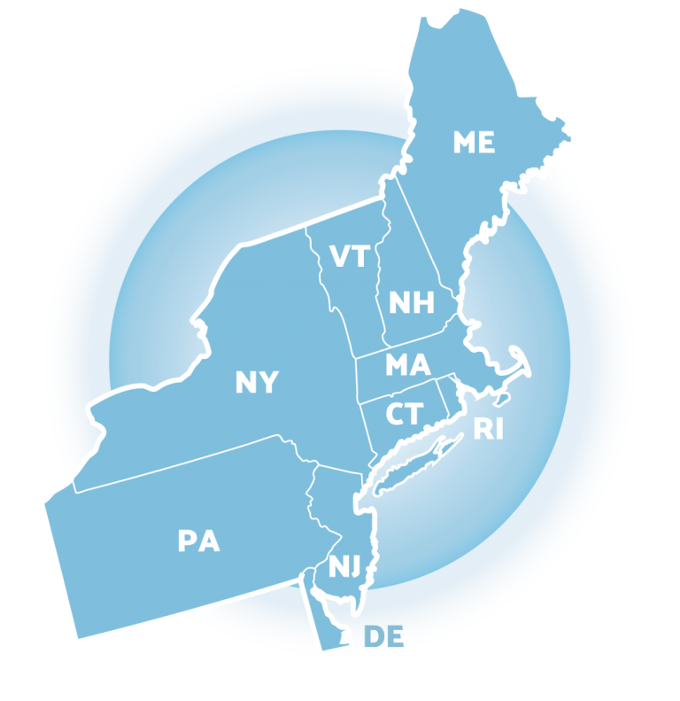

Positive Behavioral
Interventions and Supports (PBIS)
School Team Training
Tier 1 Implementation Guide

School Name _______________
Team Member Name(s) _______________________
School year ________________

Center on Positive Behavioral Interventions and Supports
Northeast Positive Behavioral Interventions and Supports
(updated 2023)

This document is supported in part by the OSEP Center on Positive Behavioral Interventions and Supports (http://pbis.org). The Center is supported by a grant from the Office of Special Education Programs, US Department of Education (H326S130004). Opinions expressed herein are those of the authors and do not necessarily reflect the position of the US Department of Education, and such endorsements should not be inferred.

Purpose

This implementation guide has been developed as an accompanying resource for school teams to use as they engage in New England Positive Behavior Interventions and Supports (NEPBIS) Tier 1 Team training. It has been designed as an organizational tool where teams can keep a record of essential discussions that occur during training, create and house implementation artifacts, and document a team’s implementation history.

Using this Implementation Guide

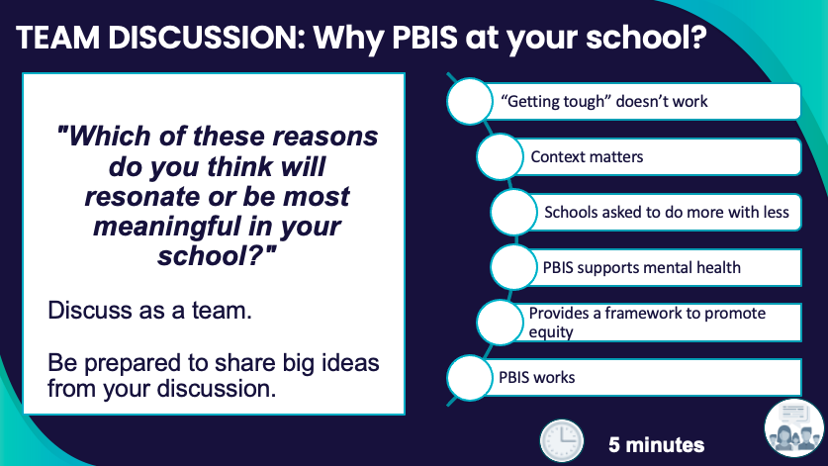
The implementation guide follows the scope and sequence of NEPBIS training days 1-11. Space has been provided for teams to engage in the activities embedded within each training day. We recommend teams use this guide during training to document the work done during each activity.

The implementation guide is best navigated using the embedded links within the Table of Contents.

It is recommended that this guide be housed in a location that provides access to all team members, including an external coach.
Sample Training Activity
Year 1 Scope and Sequence

NEPBIS Year 1 training follows the sequence below.
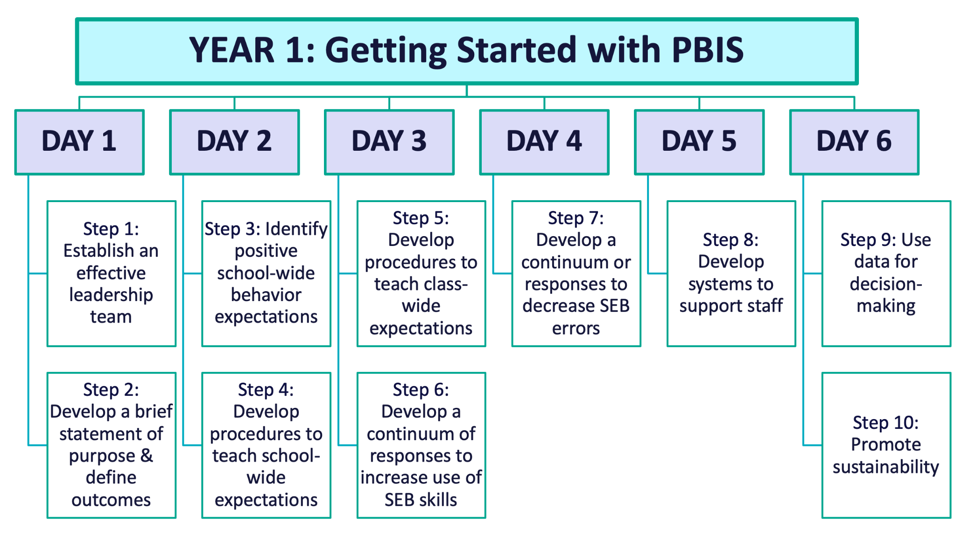

Year 2 Scope and Sequence

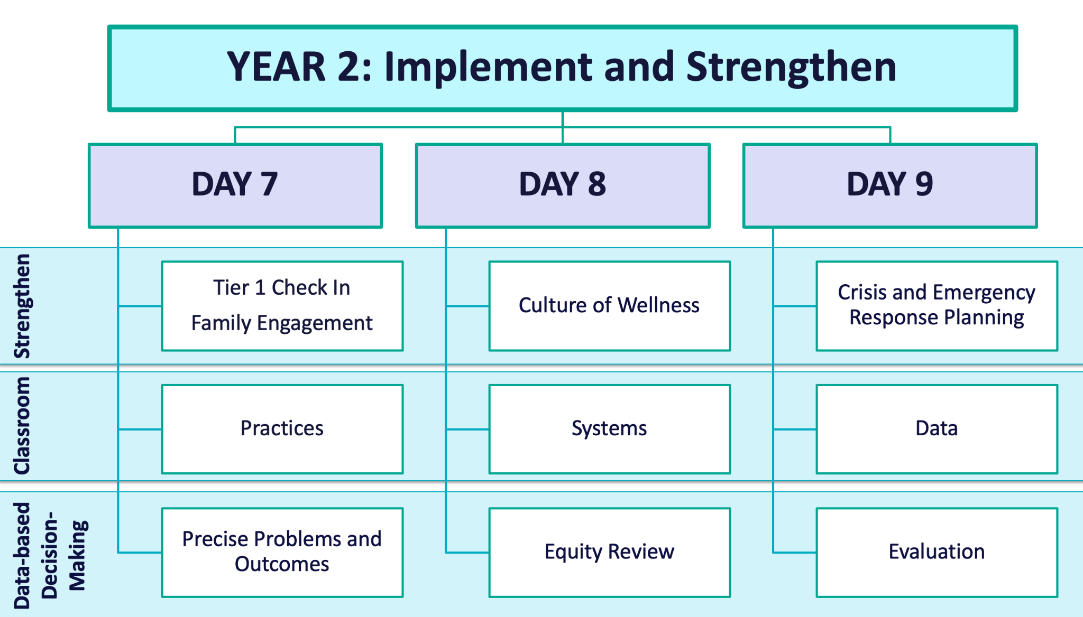

Year 3 Scope and Sequence

Table of Contents
— Training Day 1 —

Overview of PBIS
Why PBIS?
Activity: Why PBIS at your school?
What is PBIS?
Critical Features of PBIS
Activity: Outcome Data Collection
Activity: What is PBIS?
Getting Started with PBIS
Getting Started Step #1: Effective Teaming
Team Composition
Activity: Team Composition
Team Operating Procedures & Agreements
Activity: Team Roles
Activity: Team Operating Procedures
Committee Alignment/ Working Smarter
Activity: Committee Audit
Getting Started Step #2: Purpose Statement
Why Are We Doing This?
Activity: School-Wide Social-Emotional-Behavioral Purpose Statement
How Will We Get There?
Activity: Define Outcomes

— Training Day 2 —

Getting Started Step #3 School-wide Behavior Expectations
Identify Common
School-wide Expectations
Activity: Identifying Behavioral Expectations
Getting Started Step #4 Teach School-wide Expectations
Teach School-wide Expectations
Activity: Behavior Matrix
Activity: Getting Input on Expectations & Matrix
Activity: Teaching Expectations
Activity: Developing Procedures for Teaching Expectations

— Training Day 3 —
Getting Started Step #5 Teach Class-wide Expectations
Teach Class-wide Expectations
Activity: Teaching Classwide Expectations (Sample)
Activity: Considering Students’ Personal Matrices
Activity: Teaching Classwide Expectations
Activity: Team Discussion
Getting Started Step #6 Develop A Continuum of Responses to Increase Use of SEB Skills
Establishing a School-wide Acknowledgement System
Activity: School-Wide Acknowledgements Discussion
Activity: School-Wide Acknowledgement System Worksheet

— Training Day 4 —
Getting Started Step #7 Develop A Continuum of Responses to Decrease SEB Errors
Building Behavioral Capacity
Activity: Function of Behavior
Components of a Continuum of Responses to Decrease SEB Errors
Activity: Clearly Defining Behaviors
Activity: Developing Response Procedures
Activity: Behavior Referral Form
De-escalating Behavior
Activity: De-escalating Behavior
Activity: VDPs at Your School

— Training Day 5 —
Getting Started Step #8 Developing Systems to Support Staff
What are Systems?
Activity: Teaming and Action Planning
Promoting and Sustaining Staff Engagement
Activity: Promoting and Sustaining Staff
Embedded and Ongoing Professional Development
Activity: Developing a System of Embedded and Ongoing Professional Development
Staff Recognition
Activity: Developing a Staff Recognition System
Data Routines
Activity: Data Routines

— Training Day 6 —
Getting Started Step #9 Using Data for Decision-making
Why Use Data for Decision Making?
Assess Fidelity of PBIS Implementation at Least Annually
Activity: Assess Fidelity of PBIS Implementation
Review Student Behavior Data at Least Monthly
Activity: Using School-wide Behavior Data for Decision-Making
Use School and Community Data Regularly
Activity: Using School and Community Data for Decision-Making
Evaluate Your Plan at Least Annually
Activity: Using Data for Decision-Making
Getting Started Step #10 Promoting Sustainability
Planning for Ongoing Implementation & Sustainability
Planning for Rollout
Activity: Promoting Sustainability

— Training Day 7 —
Training Day 7 Activities
Tier 1 Implementation Progress Monitoring
Activity: Using the TFI to Self-Assess and Action Plan
Data-based Decision-making: Foundations
Activity: Strengthening Data Routines
Data-based Decision-making: Precise Problems & Outcomes
Activity: Precise Problem & Outcome Statements
Activity: Identify Solution, Implementation and Evaluation Plan
Classroom Practices
Activity: Promoting Positive, Proactive Classroom Practices with Staff
Monitoring Fidelity
Activity: Monitor Fidelity
Family Engagement
Activity: Family-School Practices Survey

— Training Day 8 —
Training Day 8 Activities
Establishing a Culture of Wellness for All
Activity: Supporting Student & Staff Wellness
Classroom Systems
Activity: Classroom Fidelity Data Review
Activity: Classroom Systems Self-Assessment
Equity Review
Activity: Equity Review 1
Activity: Equity Review 2

— Training Day 9 —
Training Day 9 Activities
Preparing for Crises and Emergencies
Using Your PBIS Framework When
Crises Occur
Activity: Crisis and Emergency Practice Routines
Classroom: Data
Activity: Classroom Data
Annual Evaluation
Activity: Classroom Data

Overview of PBIS

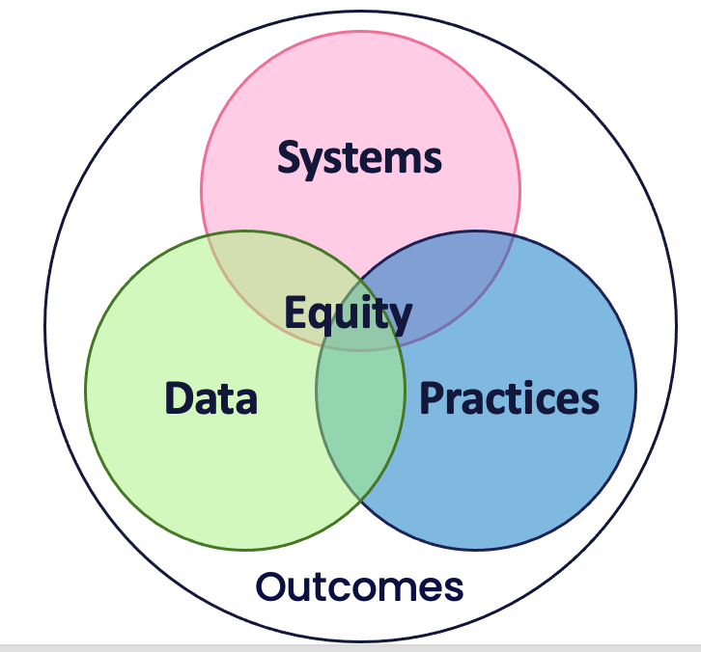

Sections:  - Why PBIS?  - What is PBIS?  - Preview of Getting Started Steps | Outcomes:  - Describe why PBIS is important for your school and what PBIS is
Related Training Materials:  - NEPBIS Day 1 Training Slides | Additional Resources:  - Anatomy of a Framework: Demystifying the Elements of PBIS  - Schoolwide PBIS Overview  - PBIS Overview video (NEPBIS)

Why PBIS?

As your school begins to explore and adopt the multi-tiered, preventative framework of Positive Behavior Interventions and Supports (PBIS), it will be important that the leadership team understands why PBIS is a valuable approach to supporting student and staff social-emotional-behavioral needs. Leadership team members are critical messengers to staff, students, families and community members.

“Getting tough” doesn’t work | - Fosters environments of control  - Triggers & reinforces antisocial behavior  - Shifts accountability away from school  - Devalues child-adult relationship  - Weakens relationship between academic & social behavior programming
Context matters | Successful individual student behavior support is linked to host environments or school climates that are effective, efficient, relevant, & durable. (Zins & Ponti, 1990)
Schools asked to do more with less | PBIS provides an evidence-based organizational framework for addressing ongoing needs:  - Returning to School During and After Crisis  - Discussing Race, Racism and Important Current Events  - Improving Attendance and Chronic Absenteeism  - Supporting College and Career Readiness  - Building a Culture of Staff Wellness
PBIS supports mental health | "Mental health includes our emotional, psychological, and social well-being. It affects how we think, feel, and act.  It also helps determine how we handle stress, relate to others, and make healthy choices. Mental health is important at every stage of life, from childhood and adolescence through adulthood." (CDC, 2021)
Provides a framework to support equity | Throughout your training and implementation,  - Access  - Representation  - Meaningful Participation  - Positive Outcomes  will be highlighted as well as the systems needed to promote and sustain equity for each and every individual.
PBIS works | Decades of evidence shows PBIS leads to positive outcomes when implemented with fidelity for students and teachers. See Is School-wide Positive Behavior Support an Evidence-based Practice? for more information.

Activity: Why PBIS at your school?
Summary of Discussion
Which of these reasons do you think will resonate or be most meaningful in your school?
Which messages do you need more support to articulate?

What is PBIS?

Organizations, including schools, which promote common experiences, language, vision/values, enveloped with quality leadership are more likely to establish positive climates for their stakeholders. Establishing a PBIS framework enhances consistency while also being responsive to diverse needs of students and staff so equitable access to positive outcomes can be achieved by all.

Schoolwide PBIS provides a proactive, preventative, multi-tiered continuum of support to match varying intensity of needs. Tier 1 includes the universal supports delivered to all students, staff and families. For those not responding to Tier 1, Tier 2 provides targeted, intensification of Tier 1 support. Tier 3, individualized support is provided to those with the most intense needs.

PBIS is…
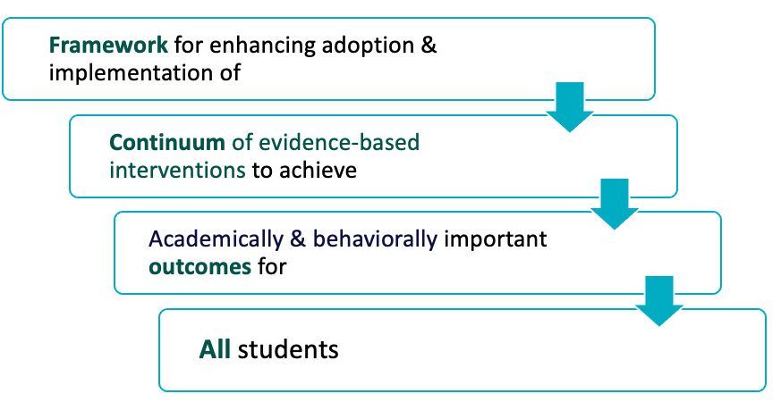

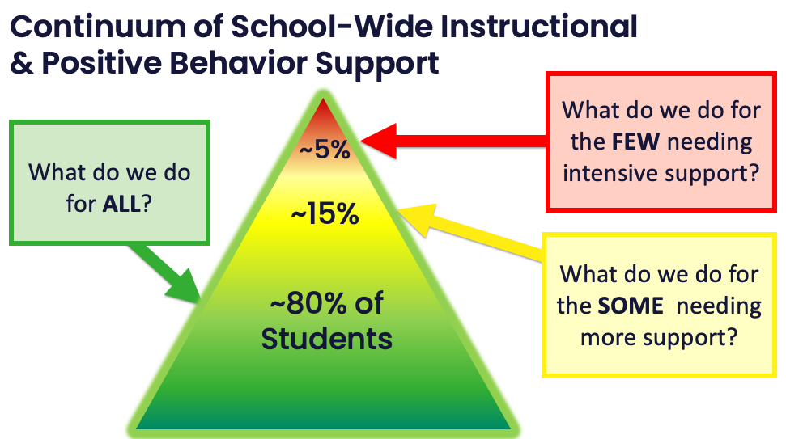

Critical Features of PBIS

To achieve the desired social-emotional-behavioral and academic outcomes for students, staff and families, schoolwide PBIS uses interconnected systems, data, and practices while centering equity in all decisions.

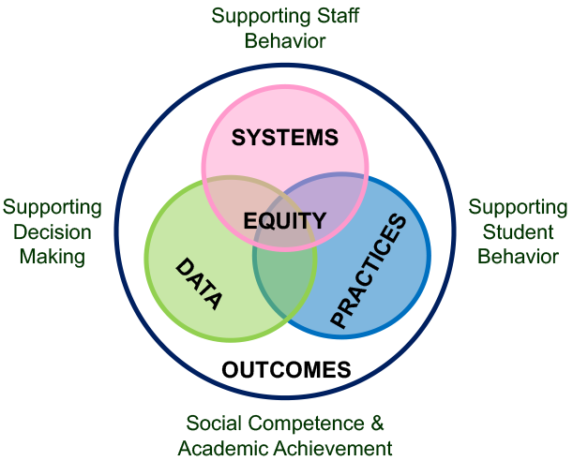

Equity | Prioritize equity. MTSS is for all students, families, and educators. Use the MTSS framework to differentiate supports for students and monitor to ensure equitable outcomes are observed
Outcomes | Make student growth and benefit central to all decisions. Student outcomes that reflect equitable learning opportunities must be the ultimate criteria for all decisions.
Data | Use data to inform decisions about which students, families, and educators need which supports, as well as whether supports should be continued, adjusted, or faded. Data should be used to ensure that all recipients experience benefit and that supports are implemented with fidelity.
Practices | Prioritize the most efficient and effective practices. Do a few important and relevant practices well. Emphasize practices that are supported by evidence, match the local culture and current context, and promote high-quality implementation across time. Integrate, align, and connect practices.
Systems | Continue to invest in systems to support high-fidelity implementation over time. Leverage existing leadership teams to guide planning and implementation, and consider effective means to support educators’ professional learning and wellness given current resources, experience, and expertise.

Activity: Outcome Data Collection
Summary of Discussion
As a team identify:

School-wide Behavior Data (SWIS is highly recommended):
How will you gather and organize your school-wide behavior data?
If your existing system meets the defined needs, verify your team can get immediate access to graphs, etc.

School Climate Data:
When will you administer your school climate surveys to students, staff and families this fall?
Second Student Outcome Data:
What student outcome (besides behavior) will your team monitor?
How will you gather the data?

Activity: What is PBIS?
Summary of Discussion
When you return to school, a colleague asks you,
"What is PBIS?
What will it look like at our school?"
How would you respond?
How will you incorporate the big ideas and critical features of PBIS into your response?

What features of PBIS were you able to clearly describe?

What features of PBIS do you need more clarity to describe?

Getting Started with PBIS

Full implementation begins with exploration and planning. The 10 steps below provide a pathway for school teams to establish a PBIS framework within their school.

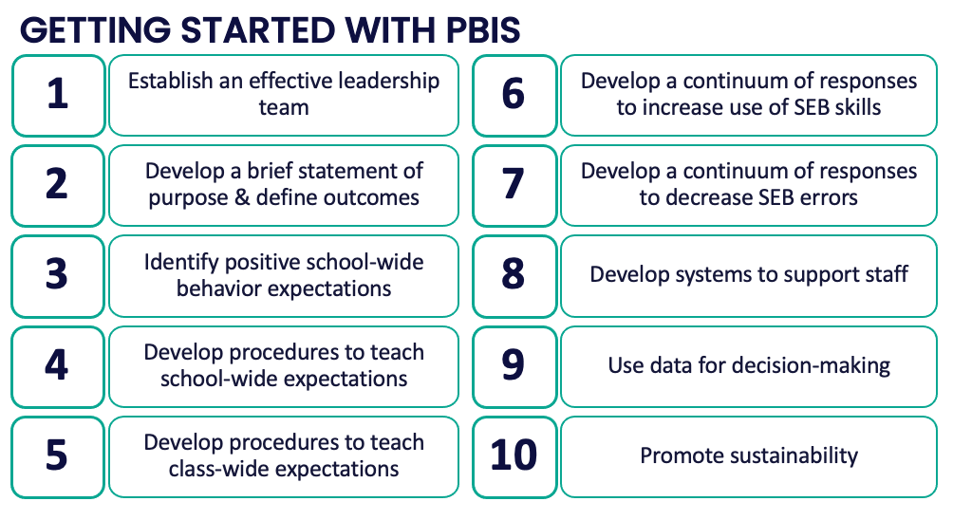

Getting Started Step #1:
Effective Teaming

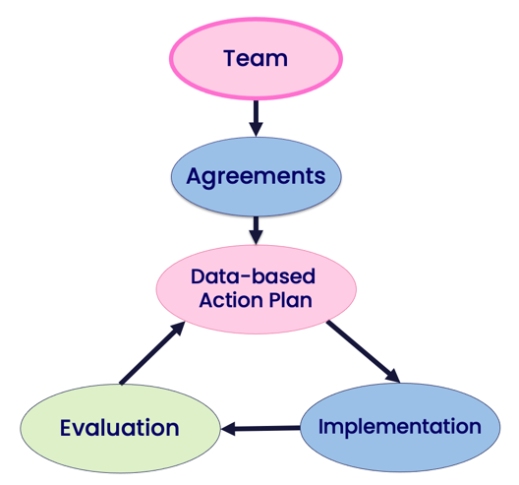

Sections:  - Team Composition  - Team Operating Procedures & Agreements  - Committee Alignment/Working Smarter | Outcome(s):  - Establish a representative team  - Establish effective team procedures and agreements  - Begin committee alignment
Related Training Materials:  - NEPBIS Day 1 Training Slides  - Sample Team Meeting Agenda  - Action Plan Templates | Additional Resources:  - Anatomy of a Framework Part 2: Teams  - NEPBIS Action Planning Video  - A Team Using TIPS: Tier I Coordination Meeting (Exploration) Video  - PBISApps Ep. 17: How to Create an Action Plan  - SWIS Readiness Checklist

Team Composition

These required, valuable roles provide essential voice to implementation efforts. While each school team may be different, all school teams should be representative. Expand the voices on your team by also engaging families, students, and community members in subcommittees, focus groups, and surveys.

Include individuals who provide expertise in:

- applied behavior support (expertise in FBA and function-based support)
- mental health and trauma
- academic instruction
- coaching
- equity
- physical health and wellness (e.g., nurse, health teacher)
- data systems and information regarding system and student academic and SEB strengths and needs

Include individuals who are representative of:

- school/community demographics
- marginalized groups

Activity: Team Composition
Team Representation | Name of Team Member(s)
Administrator (who can commit resources and actively participates)
General Education teachers
(by grade or content area)
Special Educator
Counselor or Support Personnel
Non-certified (or Classified Staff)¹
Family Member(s)²
Student(s)³
Mental Health Providers
Other (as appropriate)
¹ Representatives from non-classroom settings (e.g., office staff, cafeteria and hallway supervisor, bus driver, school resource officer, custodian, community member)
² The family member role must be filled by someone who is NOT a staff member in the school
³ Students are recommended particularly for secondary level school teams

Team Operating Procedures & Agreements

Effective team operating procedures include:
- regular meeting format/agenda that prompts the regular review of tier 1 practices, systems, and data
- minutes available to all staff for review
- established and regularly used team norms
- defined meeting roles (e.g., facilitator, recorder, time keeper, data analyst, norm keeper, action plan monitor)
- current action plan accessible to all team members
- regular (e.g., quarterly) two-way data sharing and communication with advanced tiers teams to inform decision making

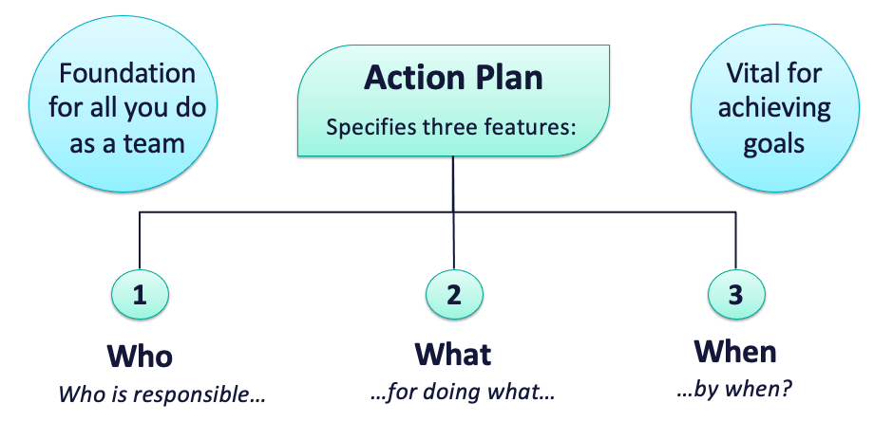

Activity: Team Roles
Team Roles | Name of Team Member
Coach(es)
Facilitator
Notetaker
Norm Keeper
Action Plan Updater (Friendly Nag)
Data Analyst
Timekeeper

SAMPLE PBIS Coordination Meeting Agenda/Notes/Action Plan
Today’s Meeting |  | Date: |  |  | Time: |  |  | Location:
Next Meeting |  | Date: |  |  | Time: |  |  | Location:
Team Membership (bold those present)
 | Name |  | Meeting Role*  (if any) |  | Name |  | Meeting Role*  (if any) |  | Name |  | Meeting Role* (if any)
Coordinators (Coaches) |  |  |  | Grade/  Department Representatives |  |  |  | Parent/ Family Member(s)
Administrator |  |  |  |  |  |  |  | Community Member(s)
Specialists
 |  |  |  |  |  |  |  | Student(s)
 |  |  |  |  |  |  |  | Other
* Meeting roles include Facilitator, Recorder, Time Keeper, Data Analyst, Action Plan Recorder, etc.
Team Agreements
Norms |  |  |  |  |  | Purpose Statement
Agenda
Today’s Items |  |  |  | Time | Discussion |  |  |  | Decisions  (add specific action items below)
Welcome, Review and Finalize Agenda
Logistics and Review of Past Action Items
Data Review and Decision Making
Practice Selection/Development
Systems for Implementation
Other
Plan for Next Meeting
Team Evaluation of Operating Procedures
Action Plan
Action Items |  |  |  |  | Notes |  |  |  |  | By Who? | By When?
Outcome Evaluation and Communication
Outcome |  |  |  | Measure Used |  | Data Collection Schedule |  |  | Data Sharing and Communication Plan
Evaluation of Team Operating Procedures (Mark your ratings with an “X”) |  |  |  |  |  |  |  |  | Yes | Partially | No
1. Was today’s meeting a good use of our time?
2. In general, did we do a good job of tracking whether we’re completing the tasks we agreed on at previous meetings?
3. In general, have we done a good job of actually completing the tasks we agreed on at previous meetings?
4. In general, are the completed tasks having the desired outcomes?
4. In general, did we do a good job following our team norms and procedures?
If some of our ratings are “Partially” or “No,” what can we do to improve things?

Activity: Team Operating Procedures
Summary of Discussion
Collaborate with your team to identify the following team procedures and agreements:
- Meeting format/agenda
- Meeting schedule
- Norms
- Action Plan Form (If using a separate document from meeting template)
- Accessible location for materials

Committee Alignment/ Working Smarter

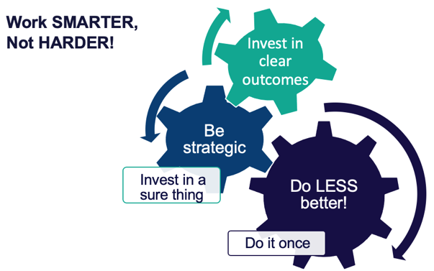
- Identify current teams (e.g., discipline, instruction, climate, etc.) and initiatives (e.g., Second Step, Character Counts, Spirit Committee, etc.) in place
- Complete the Working Smarter Table
- Review data on the Working Smarter Table to develop an action plan for eliminating or modifying teams as needed.

Activity: Committee Audit
Initiative, Committee, or Team | Purpose & Strategic Goal Supported | Measurable, Data-Based Outcome(s) | Target Group | Staff Involved | Overlap? Modify? Eliminate?

Getting Started Step #2:
Purpose Statement
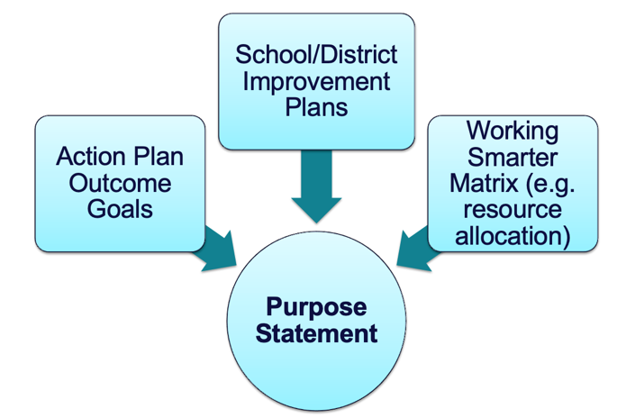

Sections:  - Why are we doing this?  - How will we get there? | Outcome(s):  - Identify purpose for implementation and define a clear outcome statement
Related Training Materials:  - NEPBIS Day 1 Training Slides | Additional Resources:  - Start With Why: How to Put Purpose Back in Your Work  - PBISApps Ep. 21: Benefits & Examples of Creating a School-wide Purpose Statement

Why Are We Doing This?

The purpose statement identifies WHY you are implementing PBIS at your school. While drafting your Purpose Statement, teams should consider outcomes/goals, school/district improvement plans, and resource allocation.

Purpose Statement guidelines:
- Positively stated
- 2 to 3 sentences in length
- Supportive of academic achievement and social-emotional-behavioral (SEB) health
- Comprehensive in scope (relevant to all students, staff & settings)

Activity: School-Wide Social-Emotional-Behavioral Purpose Statement
Development History
Drafted on (date): Presented to Faculty/Staff for review: Revised:
Final Version Shared: Post-implementation Revisions:

How Will We Get There?

Outcomes tell us if we achieve our purpose and guide framework implementation.

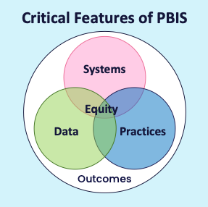
Outcome guidelines:
- Based on data
- Locally important and meaningful
- Applicable to all (culturally equitable)
  - Students’ social competence and academic achievement
  - Staff implementation of critical skills
- Observable and measurable
- Written as a goal

Activity: Define Outcomes
School-Wide Social-Emotional-Behavioral Outcome Statements
Identify 2-3 observable, measurable outcome statements for your school. | 1
 | 2
 | 3

Getting Started Step #3
School-wide Behavior Expectations

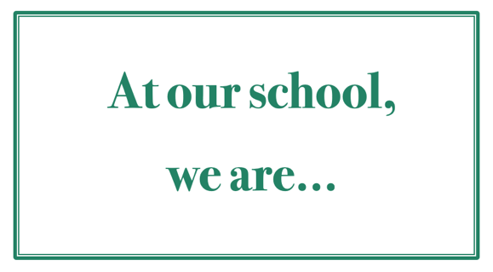

Sections:  - Identifying common contextually relevant school-wide behavior expectations | Outcome(s):  - Identify 3-5 schoolwide expectations  - Gather stakeholder input
Related Training Materials:  - NEPBIS Day 2 Training Slides | Additional Resources:  - Creating Schoolwide Expectations video (NEPBIS)  - PBIS.org Feedback & Input Surveys (FIS) Manual  - PBISApps Respect: Find Out What It Means to Me... Actually Ask Your Students

Identify Common

School-wide Expectations

Developing common school-wide expectations promotes consistency throughout the school and provides an anchor for teaching behavior expectations.

Guidelines for school-wide expectations:
- Link to social culture of school
- Consider already existing social skills
- Establish only 3-5 comprehensive expectations
- Use 1-3 words per expectation
- State expectations positively
- Support academic achievement
- Ensure expectations are mutually exclusive (minimal overlap)

Remember to gather input from stakeholders (staff, students, families) and match the culture and context of your community!

Activity: Identifying Behavioral Expectations
School-Wide Expectations
Identify 3-5 expectations for your school. | 1
 | 2
 | 3
 | 4
 | 5
Development History
Drafted on (date): Presented to Faculty/Staff for review: Revised:
Final Version Shared: Post-implementation Revisions:

Getting Started Step #4
Teach School-wide Expectations
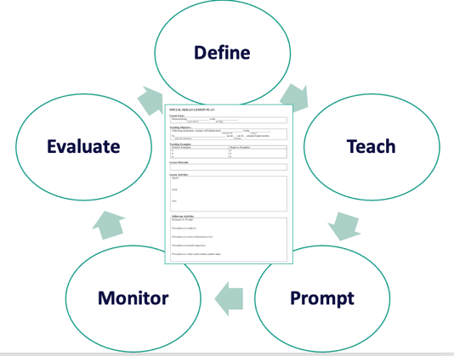

Sections:  - Teaching school-wide expectations explicitly  - Supporting staff with teaching school-wide expectations | Outcome(s):  - Create a school-wide teaching matrix  - Develop lesson plans  - Establish system for lesson plan delivery
Related Training Materials:  - NEPBIS Day 2 Training Slides  - PBIS Cultural Responsiveness Field Guide  - SWPBIS Tiered Fidelity Inventory Administration Resources  - NEPBIS SEB Lesson Plan Template  - Active Supervision Self-Assessment | Additional Resources:  - Teaching Schoolwide Expectations video (NEPBIS)  - NEPBIS.org Exemplar Repository  - PBIS.org: Sample Lesson Plan on Teaching Respect  - PBIS.org: Lesson Plan to Address Behavior

Teach School-wide Expectations

School-wide expectations need to be taught as explicitly as academic skills.

Define

Teach

Prompt

Monitor

Evaluate

A school-wide teaching matrix operationally defines what expectations look like across all settings in the school.
- Start with your school-wide expectations or norms
- Consider environmental design (i.e., physical features of the setting)
- Consider routines needed to navigate the environment
- Identify examples of how to (a) navigate the environment and (b) engage in the routines in a way that is consistent with school-wide expectations/norms

Activity: Behavior Matrix
Teaching  Matrix  School-wide Expectations: | Typical Settings/Contexts:
Development History
Drafted on (date): Presented to Faculty/Staff for review: Revised:
Final Version Shared: Post-implementation Revisions:

Activity: Getting Input on Expectations & Matrix
Summary of Discussion
Plan when and how you will get input from partners (e.g., students, families, and staff) on your schoolwide expectations and matrix.

Add items to your Action Plan as necessary

Once expectations are defined:

Define

Teach

Prompt

Monitor

Evaluate

- Teach expectations directly:
- define expectation in operational terms—tell students what the expectation looks like within each setting.
- provide students with examples and non-examples of expectation-following within each setting.
- actively involve students in lesson—game, role-play, etc. to check for their understanding.
- provide opportunities to practice expectation following behavior in the natural setting.
- Prompt or remind students of the expectation
- Monitor students’ behavior in natural context through active supervision
- Evaluate:
- the fidelity of implementation
- the effects of instruction on student outcomes

Guidelines for Teaching Expected Behaviors (Social Skills):

- Consider main school settings/contexts
- Consider lessons that already exist
- Specify 2-3 observable, positive examples for each expectation within each setting/context
- Teach social behavior like academic skill
- Provide prompts, reminders, or precorrections in natural context
- Provide specific feedback in natural context
- Develop a schedule for:
  - introducing teaching plan to staff and getting feedback on lesson plans
  - initial student instruction in natural/typical context
  - regular review, practice, and follow-up
- Develop procedures for identifying/supporting students whose behaviors do not respond to instruction
- Develop lesson plans to teach each box of your school-wide teaching matrix. Use the sample lesson plan provided below or one commonly used within your school.

Activity: Teaching Expectations
Draft components of a social skills lesson plan for one box on your matrix using the template below.
Lesson Focus
Demonstrating ______________________________ in the ___________________________.
(expectation) (setting)
Teaching Objective
Following instruction, students will demonstrate ____________________________ in the
(expectation)
_______________ by _____________________________________________________
(setting) (describe behaviors)
across _____ out of ____ sampled opportunities.
(criteria)
Teaching Examples
Examples | Non-Examples
Lesson Materials
Lesson Activities
Model:

Lead:

Test:

Follow Up Activities
Strategies to prompt:

Procedures to reinforce:

Procedures to correct behavioral errors:

Procedures to monitor/supervise:

Procedures to collect and evaluate student data:

Activity: Developing Procedures for Teaching Expectations
Summary of Discussion
Identify procedures (systems) to support staff with teaching school wide expectations.

Identify the data you will gather to monitor progress.

Add items to your Action Plan as necessary.

Getting Started Step #5
Teach Class-wide Expectations

Sections:  - Teaching class-wide expectations explicitly  - 3 Key Positive and Proactive Practices | Outcome(s):  - Create a sample class-wide teaching matrix  - Develop a sample lesson plan to teach class-wide expectations
Related Training Materials:  - NEPBIS Day 3 Training Slides  - NEPBIS SEB Lesson Plan Template | Additional Resources:  - Supporting and Responding to Students’ Social, Emotional, and Behavioral Needs: Evidence-Based Practices for Educators  - Creating a Classroom Teaching Matrix  - Creating Classroom Environments Plan Template  - PBIS Cultural Responsiveness Field Guide

Teach Class-wide Expectations

Align class-wide expectations with the school-wide expectations. Then, teach them as explicitly as school-wide expectations. Educators can engage students in identifying examples of what it looks and sounds like to meet expectations during each routine.

Teaching Expectations Framework

Define

Teach

Prompt

Monitor

Evaluate

- Define class-wide expectations by aligning them with school-wide expectations
- Teach expectations directly:
- define expectation in operational terms—tell students what the expectation looks like within each setting.
- provide students with examples and non-examples of expectation-following within each setting.
- actively involve students in lesson—game, role-play, etc. to check for their understanding.
- provide opportunities to practice expectation following behavior in the natural setting.
- Prompt or remind students of the expectation
- Monitor students’ behavior in natural context through active supervision
- Evaluate:
- the fidelity of implementation
- the effects of instruction on student outcomes

Guidelines for Teaching Class-Wide Expectations
- Develop teaching matrices, procedures, and schedules for explicitly teaching school-wide behavior expectations in typical classroom contexts and routines
- Consistently use prompts for display of expected behaviors in natural contexts
- Provide specific feedback for displays of behaviors in natural context
- Develop a school-wide action plan for supporting classroom educators to implement positive and proactive classroom practices and procedures based on data (self-assessment)

Activity: Teaching Classwide Expectations (Sample)
Teaching  Matrix  School-wide Expectations: | CLASS-WIDE ROUTINES
Development History
Drafted on (date): Shared with Students/Families:
Post-implementation Revisions:

Steps for a Personal Matrix Activity
adapted from the PBIS Cultural Responsiveness Field Guide: Resources for Trainers and Coaches
(Leverson et al., 2021)

Promote cultural responsiveness and involve staff and students in defining school-wide expectations through a personal matrix activity.

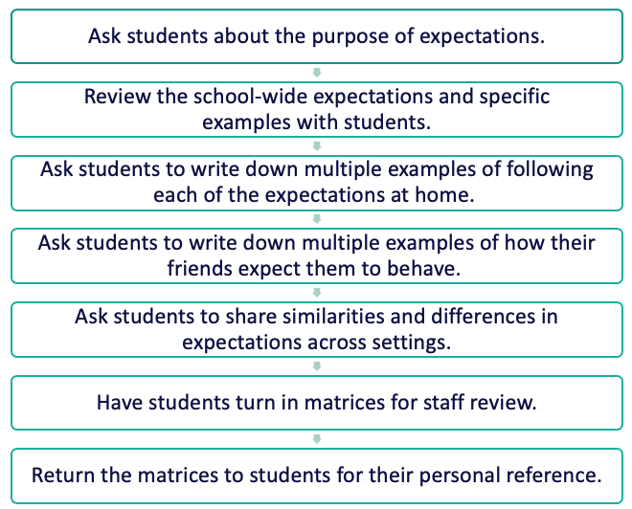

School-wide  Expectation | At SCHOOL  it looks like… | At HOME  it looks like… | In my NEIGHBORHOOD  it looks like…

Activity: Considering Students’ Personal Matrices
Summary of Discussion
Review the steps to the Personal Matrix activity (resources below).

Plan when and how you could:
- try this activity with staff;
- train staff to complete this activity with their students to inform the development of their classroom matrix.

Activity: Teaching Classwide Expectations
Draft a sample lesson plan for your staff. Develop a plan to explicitly teach 1 expectation within one routine.

Lesson Focus
Demonstrating ______________________________ in the ___________________________.
(expectation) (setting)
Teaching Objective
Following instruction, students will demonstrate ____________________________ in the
(expectation)
_______________ by _____________________________________________________
(setting) (describe behaviors)
across _____ out of ____ sampled opportunities.
(criteria)
Teaching Examples
Examples | Non-Examples
Lesson Materials
Lesson Activities
Model:

Lead:

Test:

Follow Up Activities
Strategies to prompt:

Procedures to reinforce:

Procedures to correct behavioral errors:

Procedures to monitor/supervise:

Procedures to collect and evaluate student data:

Activity: Team Discussion
Summary of Discussion
As a team, discuss how you can support classroom educators with...
- drafting their own matrices and lesson plans
- a plan for initial roll out including explicitly teaching from lesson plans at the beginning of the year and/or as new routines are introduced
- developing a plan to review/reteach in the classroom (along with non-classroom settings) at key points during the year

Getting Started Step #6
Develop A Continuum of Responses to Increase Use of SEB Skills
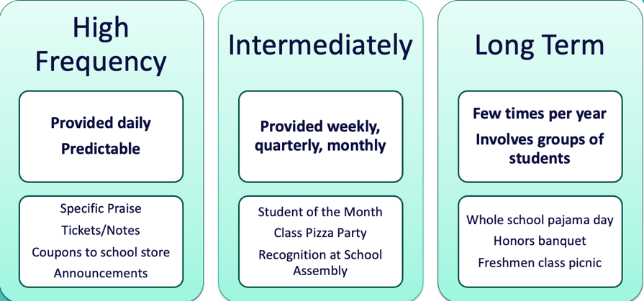

Sections:  - School-wide Acknowledgement | Outcome(s):  - Develop a school-wide acknowledgement system
Related Training Materials:  - NEPBIS Day 3 Training Slides | Additional Resources:  - Developing Acknowledgement Systems video (NEPBIS)  - PBIS.org Resource: Track Positive Reinforcement with Our Be+ App  - PBISApps 5 Ways to Reward Students the Right Way  - PBIS.org High School Acknowledgement Systems  - PBIS.org Video: Equitable Classroom Acknowledgement Systems

Establishing a School-wide Acknowledgement System

When a student experiences something desirable following a behavior, that behavior is strengthened and more likely to occur again. We need to be intentional about which behaviors are reinforced!

Praise is perhaps the most powerful and important type of acknowledgement.
Therefore, any acknowledgement system needs to be paired with specific praise!

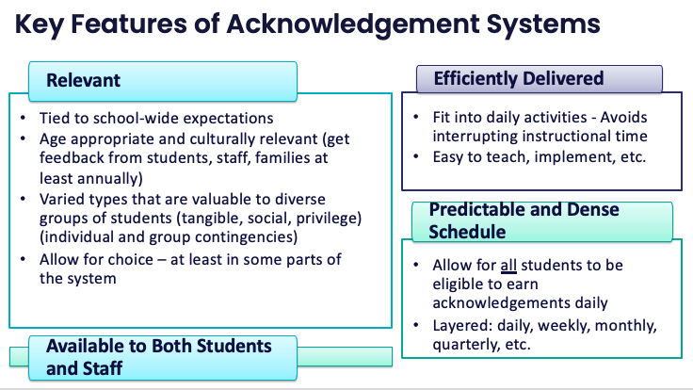

Guidelines for Continuum of Responses to Increase Use of SEB Skills
Develop:
- Easy and quick forms of acknowledgement linked to SW-expectations and used across all settings (non-classroom and classroom) which is considerate of strategies/processes that already exist
- Culturally, developmentally, contextually appropriate/relevant name and form of acknowledgement
- Written procedures for delivering acknowledgements
- Back-up or follow-up acknowledgements
- Means for keeping track of the ratio of acknowledgements to referrals or corrective actions

Activity: School-Wide Acknowledgements Discussion
Consider how you would respond to the following questions about acknowledgement. Your team should have a consistent message.
Is it fair to all students?
They are in high school, and students don’t need to be acknowledged.
It’s bribery!
Why can’t we just tell them they’re doing a good job?
You’re building a token society.
Why are we rewarding them for what they’re supposed to do?

Activity: School-Wide Acknowledgement System Worksheet
As a team, begin drafting your acknowledgement worksheet.
 | High-Frequency | Intermittent | Long-term
Name of Acknowledgement
Description
Criteria for Receipt
Resources Needed
Deliver by Who?
When and Where?
How Often?
Staff communication:
What? By who? When?
How will staff be supported to implement this with fidelity?
Goal for this practice
How will you know if you have reached your goal?

Getting Started Step #7
Develop A Continuum of Responses to Decrease SEB Errors
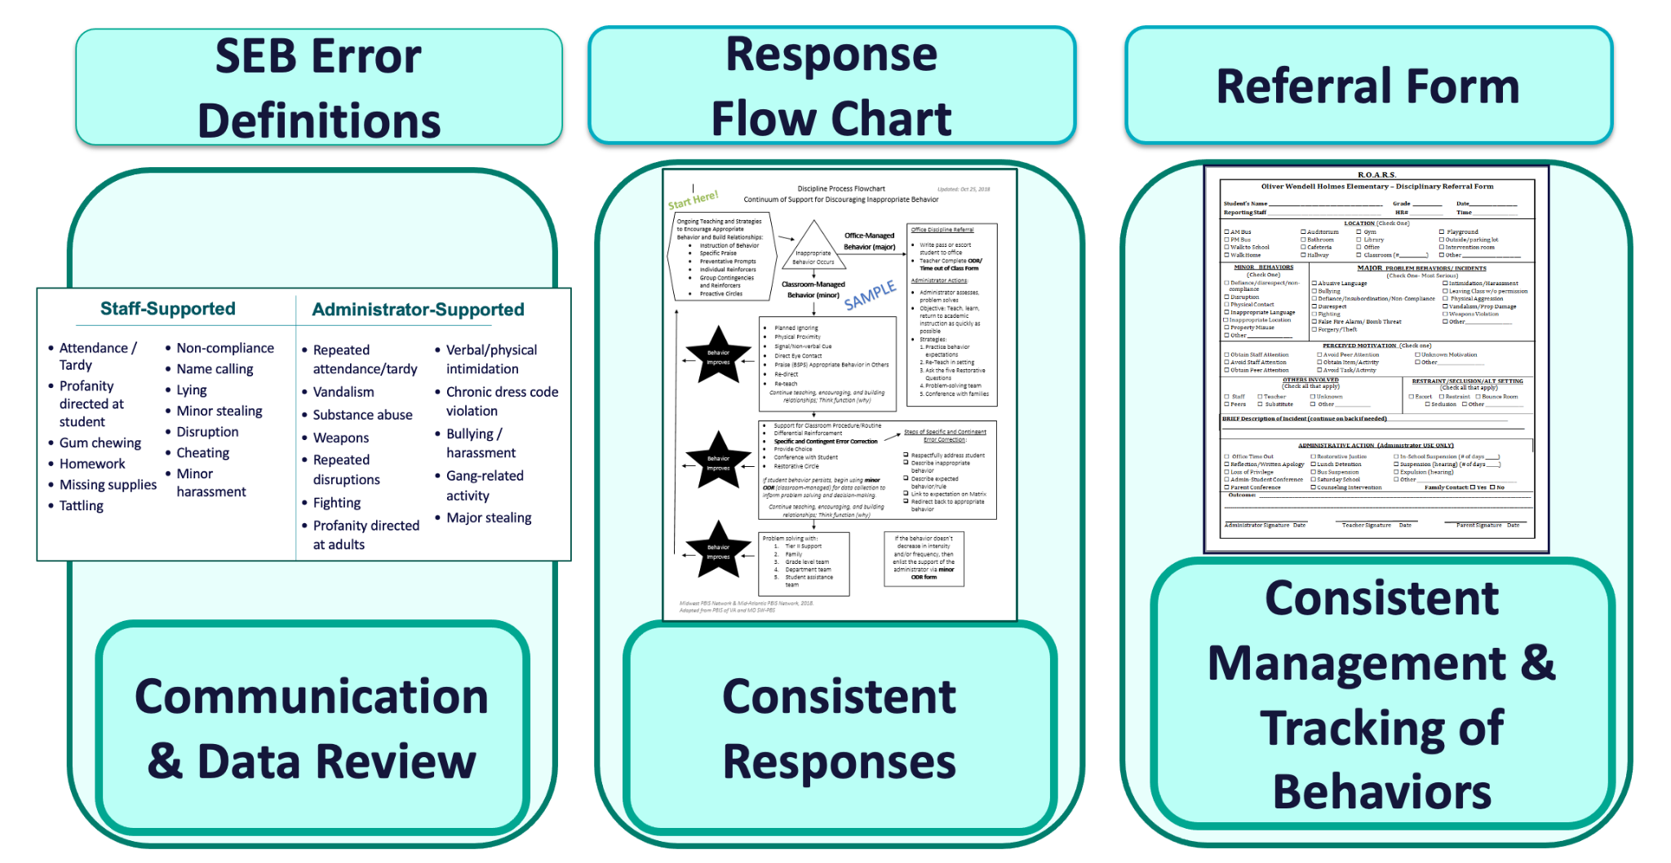
Sections:  - Building Behavioral Capacity  - Components of a Response Continuum  - De-escalating Behavior | Outcome(s):  - Understand function-based logic for responding to contextually inappropriate behavior  - Develop response continuum components  - Understand strategies for de-escalating and avoiding power struggles
Related Training Materials:  - NEPBIS Day 4 Training Slides | Additional Resources:  - Function of Behavior videos (NEPBIS)  - PBISApps Putting a Definition Back in Defiance  - SWIS Referral Category Definitions  - PBISApps Minor Behavior Documentation Log Template  - Strategies for De-escalating Student Behavior in the Classroom  - NEPBIS SWIS Alternative Tool

Building Behavioral Capacity

Contextually inappropriate behavior includes behaviors or actions that are inappropriate in a given context but may be appropriate in another context. We intentionally use the term contextually inappropriate behavior rather than unwanted or inappropriate behavior to emphasize the role of context in judgments about what behaviors are and are not accepted.

A Basic Understanding of the Science of Behavior Change:
- Gives us tools to observe, measure, teach, and correct behaviors effectively and efficiently.
- Moves us away from perceptions, opinions, and assumptions about motivations or intentions
- Shares the following assumptions:
  - Behavior is communication
  - Behavior occurs in the context of an antecedent and consequence
  - Behavior is learned
  - Behavior is lawful
  - Behavior is escalated through successive interactions
  - Behavior can be changed through an instructional approach

Antecedent

“Stimulus that precedes a behavior”

Behavior

”Observable and measurable act of an individual (also called a response)”

Consequence

Stimulus change that occurs contingent on a behavior

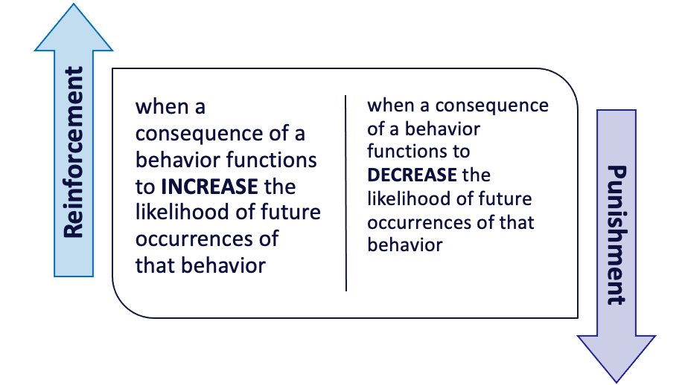

All behavior serves a function. “Function” = outcome, result, purpose, consequence

Get/Obtain

desired activities
tangible items
attention
sensory stimulation

Avoid/Escape

aversive activities
tangible items
attention
sensory stimulation

To determine the function of a behavior over time, consider
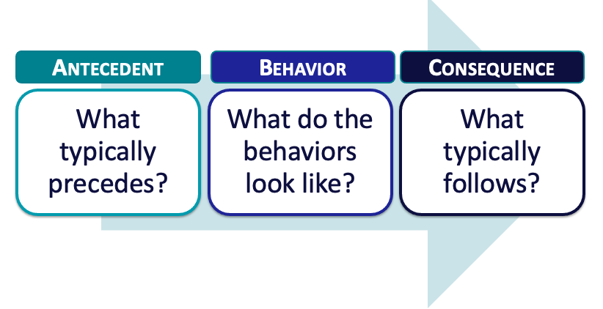

By understanding function, we can intervene more effectively.

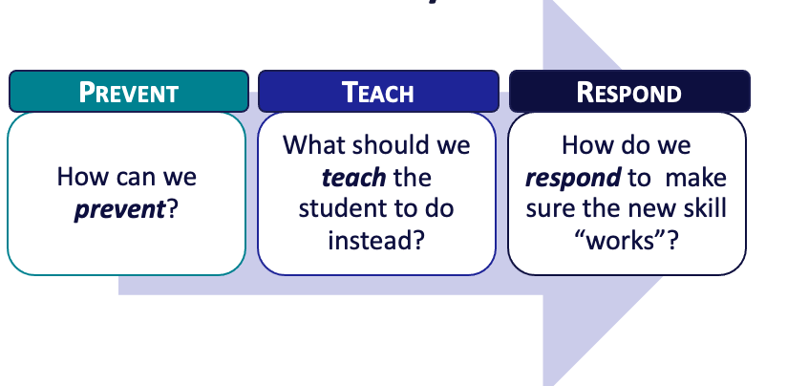

Activity: Function of Behavior
Identify a common contextually inappropriate behavior in a non-classroom or classroom setting

Describe the “ABCs” | Antecedent | Behavior | Consequence
Identify strategies to prevent, teach, and respond/reinforce | Prevent | Teach | Respond/Reinforce
Summary of Discussion
Consider how you will teach function-based thinking to your staff and add items to your Action Plan as necessary.

Components of a Continuum of Responses to Decrease SEB Errors

Establishing a continuum of responses to decrease SEB errors ensures that the same consequence is not applied to all SEB errors occurring in a school, establishes a hierarchy from least to most severe consequences aligned with SEB errors and better addresses the needs of a variety of students.

Critical Features of a Continuum of Responses to Decrease SEB Errors
- Relate to the function of the behavior!
- Align with clearly defined school-wide expectations
- Exist as one component of a larger system of behavior change for the student.
- System of support exists including review, teaching, and monitoring of current responses to problem behavior

Organizing Responses: 3 Important Components

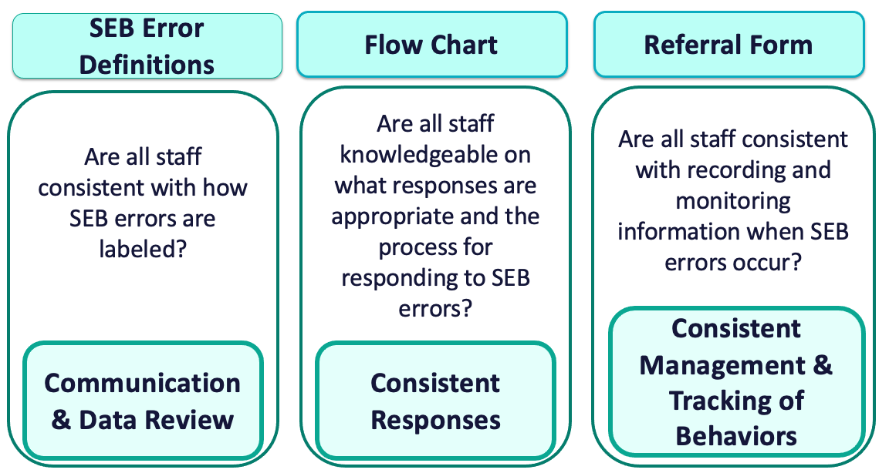

Guidelines for a Continuum of Responses to Decrease SEB Errors:

Ensure SEB Error Definitions are:
- contextually appropriate
- representative of a continuum of severity (e.g.,staff-supported, administrator-supported, illegal)
- comprehensive in scope (school-wide)
- written in measurable terms
- mutually exclusive (minimal overlap)
- support agreement regarding office/administrative vs. teacher/staff responsibilities

Establish Response Procedures for SEB errors:
- Agreement regarding options for continuum of consequences
- Series of responses that support students’ quick return to instructional activities
- Schedule for regular review of use and effectiveness
- Means for keeping track of number of acknowledgments vs. referrals or other disciplinary actions
- Procedures for identifying and supporting students whose behaviors are not responsive

Ensure the Referral Form for SEB errors includes:

Who… | engaged in the SEB error  observed and responded  else was involved
When… | Day  Time
Where… | Locations throughout the school
What… | SEB error occurred  was the possible motivation

Activity: Clearly Defining SEB Errors
SEB Error Definitions
Staff-Managed | Administrator-Managed

Activity: Developing Response Procedures
SEB Errors Flowchart
*It may be easier to build your team’s flowchart using an online application and insert it here. Consider using Google Slides, Powerpoint, or Canva

Activity: Referral Form

De-escalating Behavior

Preventing escalated behavior is key! When behaviors do happen, it is essential that adults remember their role and utilize self-management and neutralizing routines. These adult actions occur before, during, and after behaviors.

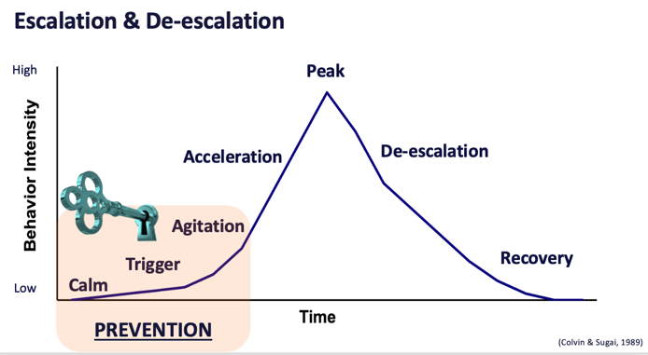
Key Prevention Strategies
- Identification of how to intervene early in an escalation.
- Identification of environmental factors that can be manipulated.
- Identification of replacement behaviors that can be taught (& serve same function as problem).

Effective Neutralizing Routines…
- Use If-then statements
- Are brief
- Have clear steps
- Are doable
- Interrupts the chain of events

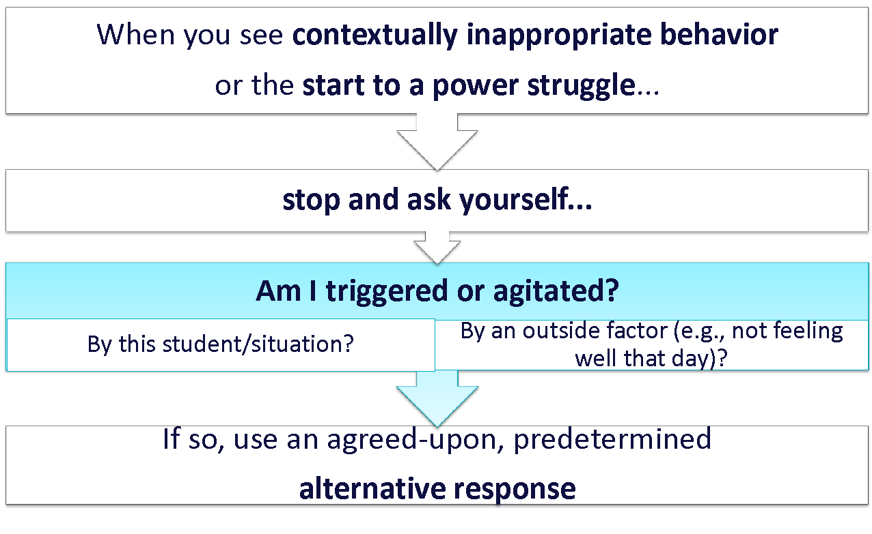

Activity: De-escalating Behavior
Summary of Discussion
Discuss the extent to which de-escalating behavior is or could be an issue in your school.

Identify 2-3 examples of neutralizing routines that you could share with staff.

What is Implicit Bias?
- Unconscious, automatic
- Based on stereotypes
  - We all have it (even those affected by it)
  - Generally not an indication of what we believe or would endorse
  - More likely to influence:
  - Snap decisions
  - Decisions that are ambiguous

Reduce Effects of Implicit Bias through Specific Training
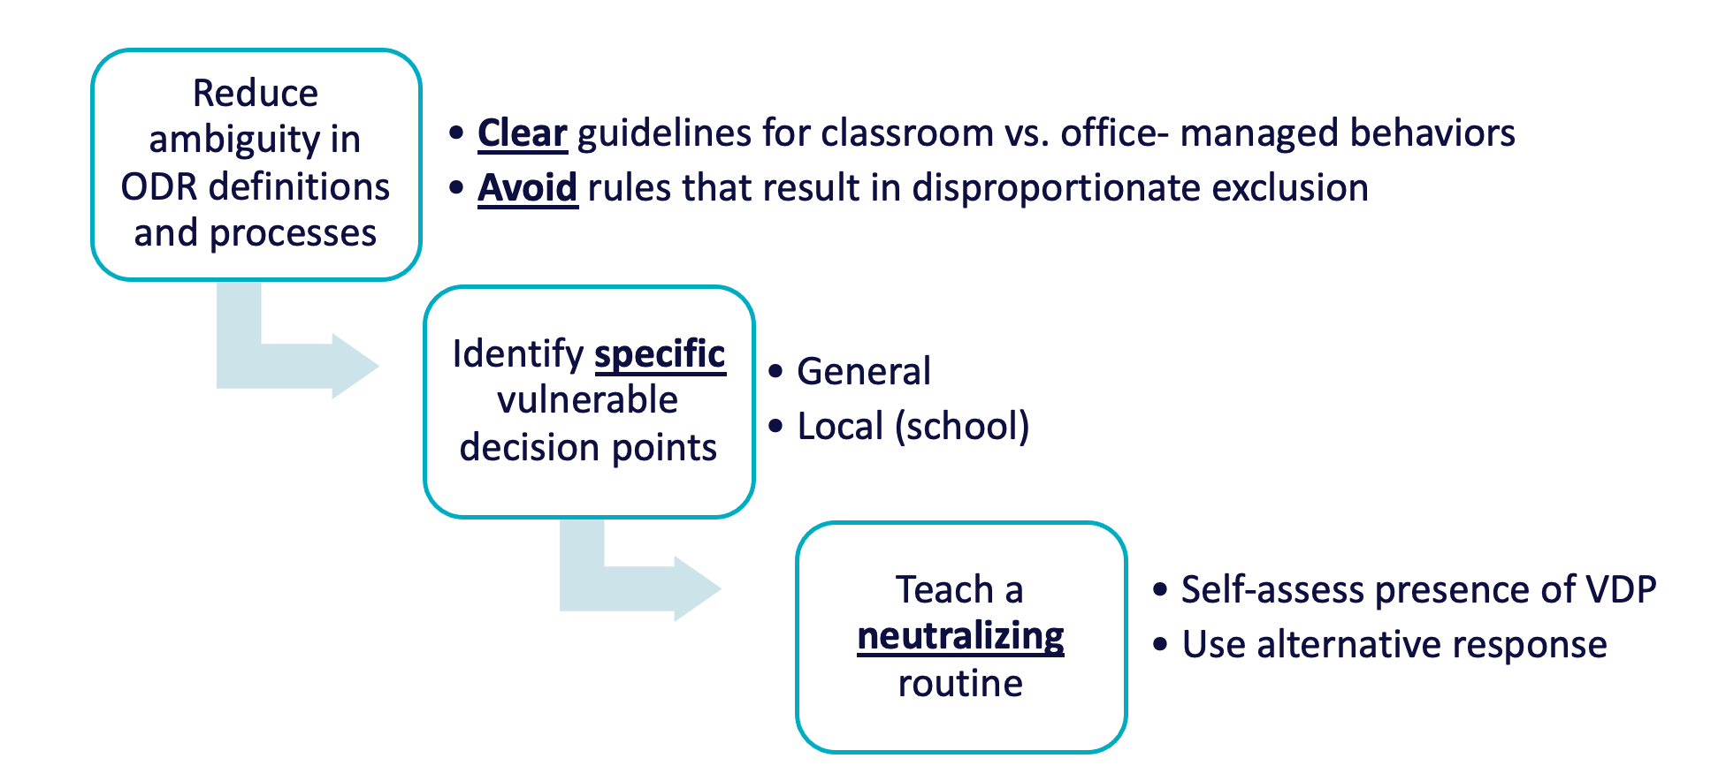
adapted from the PBIS Cultural Responsiveness Field Guide: Resources for Trainers and Coaches (Leverson et al., 2021)

Activity: VDPs at Your School
Summary of Discussion
What are some potential triggers that may lead to VDPs for staff?

How could those triggers be minimized?

Which contexts within your school are ambiguous and more likely to contribute to VDPs?

How can those contexts be altered to reduce ambiguity and/or promote neutralizing routines?

Getting Started Step #8
Developing Systems to Support Staff
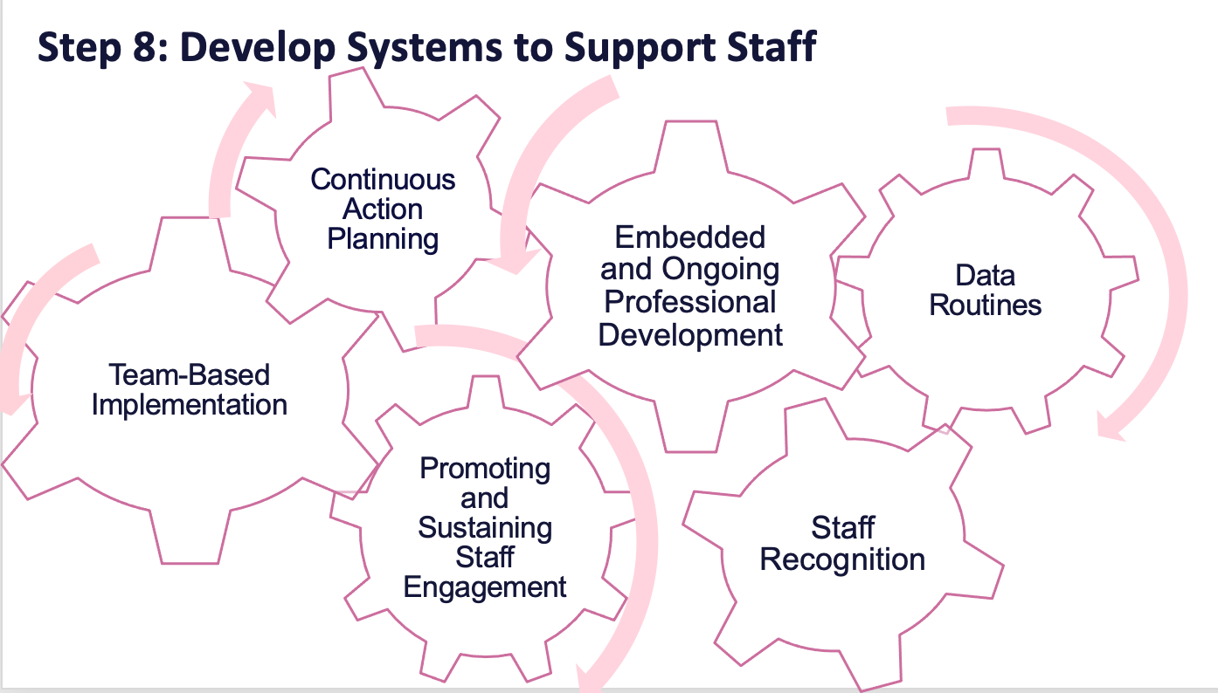

Sections:  - What are Systems?  - Promoting and Sustaining Staff Engagement  - Embedded and Ongoing Professional Development  - Staff Recognition  - Data Routines | Outcome(s):  - Ensure team and action planning systems are in place  - Strengthen staff engagement  - Develop systems for professional development/coaching  - Install a staff recognition system  - Establish data routines
Related Training Materials:  - PBIS Day 5 Training Slides | Additional Resources:  - PBIS.org Building a Culture of Staff Wellness Through Multi-Tiered System of Supports  - PBISApps Your Foolproof Plan to Create Staff Buy-In That Sticks  - PBISApps Ep. 14: Relieving Staff Stress with System-level Solutions

What are Systems?

The way schools operate are their foundational systems. In PBIS, these systems support: accurate, durable implementation of practices and the effective use of data to achieve better outcomes (pbis.org).
In other words…
systems are what we do to support the adults!

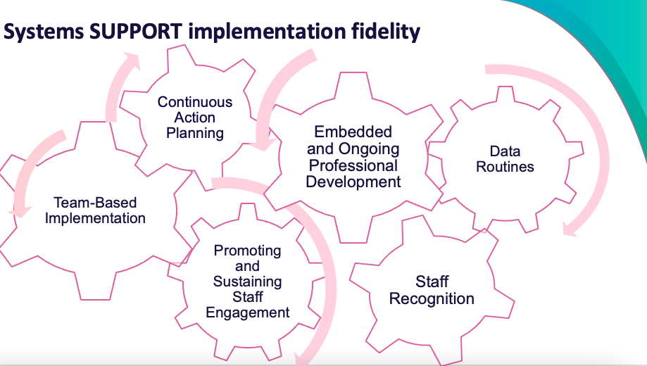

Use systems to prioritize your team’s effective action planning:

- Accessible to all on the team
- Review action plan at each meeting
- Use data to identify next steps
- Align to desired outcomes

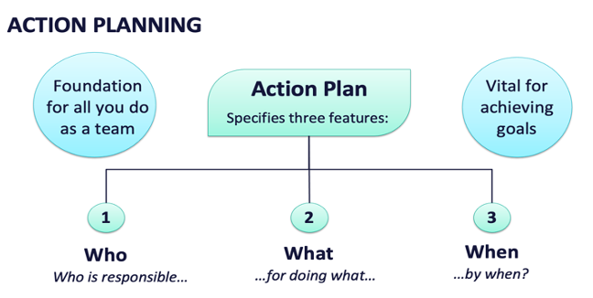

Activity: Teaming and Action Planning
Summary of Discussion
As a team, reflect on your teaming procedures including:
- effective meeting routines (scheduling, agendas, minutes, etc.)
- maintaining a representative, active team membership
- accessible, functional action planning

Identify what worked well and what can be improved.

Promoting and Sustaining Staff Engagement

Staff Engagement is critical for Implementation. It has been identified as a significant factor driving sustaining implementation (McIntosh et al., 2013) and the top thing that makes everything fall apart when it was missing (Pinkelman et al., 2015). Further, lack of staff buy-in is the most commonly reported reason for abandonment (Kittleman et al., 2020).

Strategies to Promote and Sustain Staff Engagement:
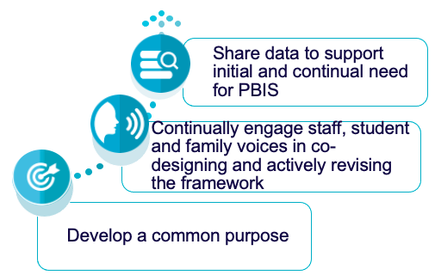
Guidelines for Staff Engagement:
- Use data to establish need
- Self-assessment
- Baseline discipline/behavior/climate data
- Maintain an effective team with active administrator participation
- Present information in clear and efficient way(s)
- Obtain and incorporate feedback on all elements of SWPBIS from staff
- Start small and demonstrate success

Activity: Promoting and Sustaining Staff
Summary of Discussion
As a team, discuss how you will promote and sustain staff engagement by:
- Reinforcing your common purpose
- Enhancing staff voice throughout implementation efforts
- Continuously sharing relevant data

Embedded and Ongoing Professional Development
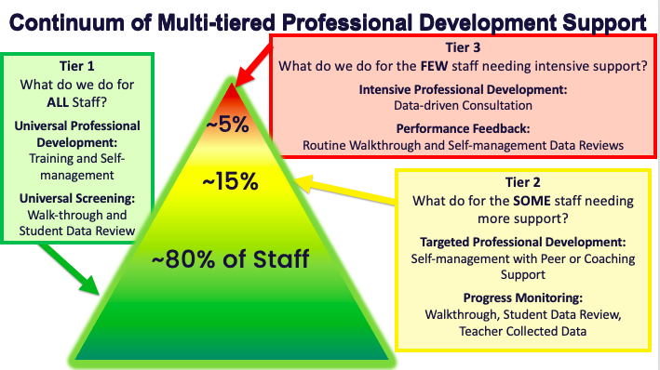

Identify what staff need to know, then provide:
Explicit Training: | Coaching/Prompting: | Performance Feedback
- Model, lead, test format  - Demonstrate desired skill (I do)  - Provide effective examples/non-examples  - Provide sufficient group practice (We do)  - Provide opportunities to demonstrate and receive feedback (You do)  - Connected to/embedded in typical practice/routines  - Brief training/practice spaced out | - Prompt and remind educators of targeted practices implementation.  - Provide supportive data-based feedback and suggestions for improving implementation. | - Data-based feedback (based on self-, peer-, or consultant collected data)  - Summary of key observations  - Delivered frequently (daily or weekly)  - Specific suggestions for improvement or acknowledgements of good performance

Guidelines for Embedded and Ongoing Professional Development:
- Ensure PD includes explicit training, performance feedback and ongoing coaching
- Develop a PBIS PD Calendar and routines (e.g. 15 minutes of every staff meeting, 1 hour of early release days)
- Align staff evaluation procedures with expected practices where possible

Activity: Developing a System of Embedded and Ongoing Professional Development
Summary of Discussion
Consider how you will provide embedded and ongoing professional development to staff that includes:

- Explicit training
- Coaching/prompting
- Performance feedback

Staff Recognition

Adults need and deserve recognition for their PBIS implementation efforts. Just as we want to promote contextually appropriate behavior with our students, we also want to acknowledge adults for:
…positively and proactively engaging with students
…implementing PBIS practices
…providing valuable input
…and so much more!

Guidelines for Staff Recognition
- Develop easy and quick forms of acknowledgement
- Consider strategies/processes that already exist
- Ensure the name and form of acknowledgment is culturally, developmentally, and contextually appropriate
- Consider back-up or follow-up acknowledgements
- Schedule an initial introduction of acknowledgements and regular boosters or reimplementation of acknowledgements

Activity: Developing a Staff Recognition System
Summary of Discussion
As a team, brainstorm ideas for recognizing your staff’s implementation efforts.

Consider how you will gather staff feedback on the plan.

Data Routines

Use data to inform decisions about which students, families, and educators need which supports, as well as whether supports should be continued, adjusted, or faded. Data should be used to ensure that all recipients experience benefit and that supports are implemented with fidelity.

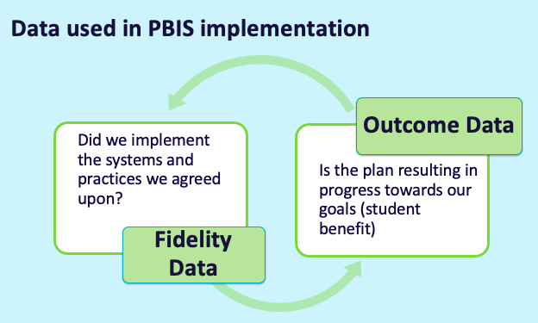

Establish and Strengthen Data Routines
Identify the RIGHT data | Assess data INTEGRITY | Identify the RIGHT people | Identify the RIGHT time & format
Outcome data tied to goals  Fidelity data tied to evaluation plan | Consider staff training & engagement, systems, response rates | Who needs to see these data to inform decisions? (e.g., PBIS team, grade level teams, family groups, other committees?) | When/how often should these data be reviewed?  What format will facilitate decision making?

Establish Routines to Share Data with Partners Regularly
The frequency that data are presented to all school staff is the factor most related to high levels of sustainability (Pinkelman et al., 2015). Share with other partners to increase commitment, accountability, and support.

Guidelines for Efficient Data Collection Routines
What Data?
- Limit to information that answers important student, classroom, and school questions

How should information be gathered?
- Integrate data collection procedures into typical routines (e.g., referrals, attendance, behavior incident reports)
- Schedule data collection and staffing to ensure that data are current

When?
- Use no more than 1% of time each day for managing data

By whom?
- Ensure access to all necessary information (e.g., student records)
- Check data collection reports regularly for accuracy

Guidelines for Efficient Data Review Routines
- Protect team time to review data monthly: Identify 2-3 staff members to:
- manage data systems
- provide efficient, timely, and graphic displays of data

- Establish structures and routines for staff members to receive weekly/monthly data reports about status of SW discipline

Activity: Data Routines
As a team, review your evaluation plan and identify what still needs to be completed this year. Plan your data routines for the year ahead.
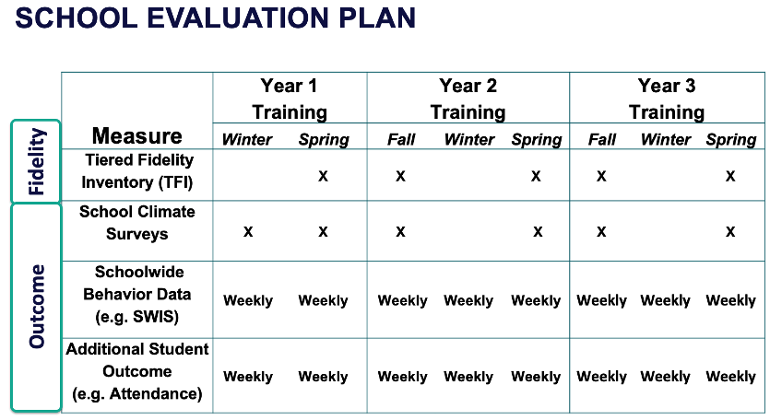

Data Source | Date(s) for admin. | Who brings data to team meeting | Meeting date to review data | Plan to share data
TFI
Referrals
School Climate
Other Outcome

Getting Started Step #9
Using Data for Decision-making
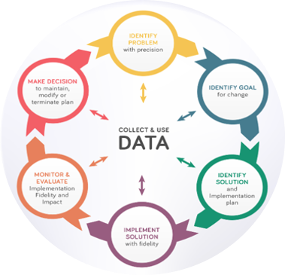

Sections:  - Why Use Data for Decision Making?  - Assess Fidelity of PBIS Implementation at Least Annually  - Review Student Behavior Data at Least Monthly  - Use School and Community Data Regularly  - Evaluate Your Plan at Least Annually | Outcome(s):  - Assess and evaluate PBIS fidelity of implementation  - Identify a schoolwide behavior problem and potential solution  - Evaluate perceptions of school climate for students, staff and families
Related Training Materials:  - NEPBIS Day 6 Training Slides  - NEPBIS Annual Tier 1 Evaluation Report Template  - NEPBIS Annual Tier 1 Evaluation Report Sample | Additional Resources:  - How School Teams Use Data to Make Effective Decisions (Chaparro et al., 2022)  - School Climate Survey Suite (Center on PBIS, 2022)  - PBISApps Ep. 18: The Fundamentals of Data-driven Decisions

Why Use Data for Decision Making?

Decisions are more likely to be effective and efficient when they are based on data. The quality of decision making depends most on defining problems with precision & clarity. Data help place the “problem” in the context rather than in the students. Use data to monitor implementation and outcomes, guide implementation, engage in problem solving, identify and refine problems, and define the questions that lead to a solution.

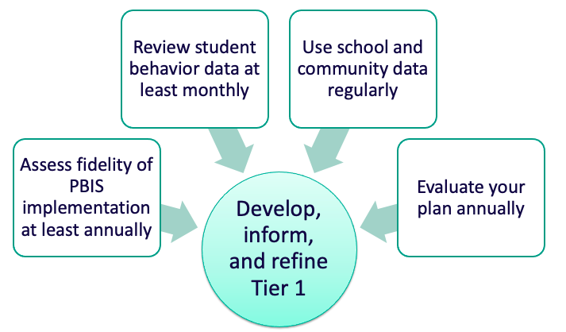

Assess Fidelity of PBIS Implementation at Least Annually

Tiered Fidelity Inventory
Why? | - Assess evidence of critical features of school-wide PBIS implementation  - Monitor progress over time  - Helps team make data-based decisions on intervention and program efficacy  - Guides action-planning
What? | Survey ratings of features in place.  About 30-45 mins per tier.
Who? | Team members with the coaches.  Walkthrough tool completed by external coach.

Activity: Assess Fidelity of PBIS Implementation
Summary of Discussion
Review your school’s most recent Tiered Fidelity Inventory (TFI) data as a team.
What feature(s) are the highest priority for improvement for your team? How will you move your implementation forward in those key areas?

Add items to your Action Plan as necessary.

Review Student Behavior Data at Least Monthly

Gather incidents…analyze trends…. ask questions!

Guiding Question |  | Data Source
Do we have a school wide problem with behavior (Tier 1)? | → | Average Referrals Per day Per Month
Where is our big problem area? | → | Referrals Per Location
What contextually inappropriate behavior happens most frequently? | → | Referrals by Problem Behavior
What grade levels need more support? | → | Referrals by Grade
When do problems occur? | → | Referrals by Time of Day
Are students responding to our systems? | → | Triangle Report
What is the risk for students within each group to receive a referral? | → | Risk Index
For a given group of students, how much more or less likely are they to receive at least one referral than students from another group? | → | Risk Ratio
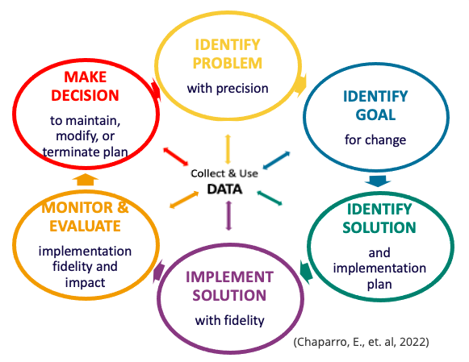

Activity: Using School-wide Behavior Data for Decision-Making
Summary of Discussion
Review your school-wide behavior data.

Apply the decision-making steps to 1 current problem in your school.

Add to your action plan, as needed.

Use School and Community Data Regularly

At the very least, schools should be reviewing office discipline referrals and school climate surveys plus another existing data source. This additional data source could be attendance, grades, referrals to special education, nurse/counselor visits, and universal screeners.

School Climate Survey
- Assess students’, staff, and families’ perspective of the overall climate in the building;
- Completed in fall and spring;
- Designed for Elementary (grades 3-5), middle (grades 6-12), staff, and families;

Sources of Community Data:
- Community resource profiles
- Basic needs (e.g. food and housing)
- Health care access
- Community events

Activity: Using School and Community Data for Decision-Making
Summary of Discussion
Identify what school and community data is needed for your team to develop, inform, and refine Tier 1 in your school.

Apply the decision-making steps to 1 current problem in your school.

Add to your action plan, as needed.

Evaluate Your Plan at Least Annually

Evaluating your plan provides opportunities for your team to:
- examine whether or not outcomes were achieved
- celebrate accomplishments
- identify areas to strengthen
- share impact and insight with partners

Fidelity Data | + | Outcome Data | = | Celebrations,  Areas to Strengthen,  Action Steps

Activity: Using Data for Decision-Making
Summary of Discussion
What data will your team plan to report out next year?

What systems/routines need to be strengthened to effectively support data-based decision-making?

Add items to your action plan as needed.

Getting Started Step #10
Promoting Sustainability
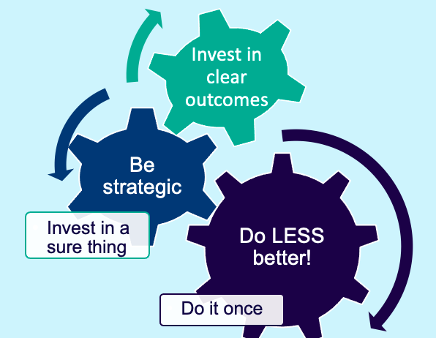

Sections:  - Planning for Ongoing Implementation & Sustainability  - Planning for Rollout | Outcome:  - Plan for roll-out  - Plan for ongoing implementation
Related Training Materials:  - NEPBIS Day 6 Training Slides | Additional Resources:  - PBISApps Be a Data Hero: Sustaining Practices and Sharing Data  - PBISApps Implementation Fidelity: It's More Than a Score  - PBISApps The Second Year Itch: Why Does Implementation Fail?

Planning for Ongoing Implementation & Sustainability

Three essential actions will promote ongoing PBIS implementation: scheduling time, organizing resources, and working smarter, not harder.

Key Factors for Sustaining PBIS:
Maintain a strong team | Step 1
Use your fidelity of implementation data to improve your systems | Step 9
Use your school discipline data | Steps 7 & 9
Implement PBIS in the classroom | Step 5

Guidelines for Promoting Sustainability
- Work as a team.
- Make decisions based upon data.
- Consider the needs of each and every student.
- Support staff with implementation.
- Integrate PBIS activities into other initiatives and projects.
- Begin teaching, learning, and behavioral expectations on the first day.
- Involve students, staff, parents, and community at all steps.
- Keep this implementation guide updated as a documentation of team decisions and components of your PBIS framework.

Planning for Rollout
Essential Questions:
Q. Have you established training/teaching content and routines to support each audience?
- Staff | - Students | - Families | - Communities

Q. How will you orient students, staff, and families that arrive in your school throughout the year?

Activity: Promoting Sustainability
Summary of Discussion
As a team, schedule necessary activities (meetings, teaching expectations, PD, evaluation plan, etc.).

Organize your resources and plan documents.
Revisit your Working Smarter matrix from Day 1 and revise as needed.

Consider what needs still exist for rollout.

Add items to your action plan as needed.

Training Day 7 Activities
Sections:  - Tier 1 Self-assessment  - Data-based Decision-making  - Foundations  - Precise Problems and Outcomes  - Classroom Practices  - Family Engagement | Outcome:  - Identify Tier 1 implementation strengths and action items  - Plan for incorporation of data routines  - Identify 1-2 precise problems, outcomes, solutions, and implementation plans  - Plan explicit training for classroom educators  - Gather fidelity data  - Identify action steps to increase family engagement
Related Training Materials:  - NEPBIS Day 7 Training Slides | Additional Resources:  - Tiered Fidelity Inventory 2.1  - Supporting & Responding to Students Social, Emotional, and Behavioral Needs  - Aligning and Integrating Family Engagement in Positive Behavioral Interventions and Supports

Tier 1 Implementation Progress Monitoring

Consider the 10 Getting Started Steps when assessing Tier 1 Implementation:

Activity: Using the TFI to Self-Assess and Action Plan
TFI Score & Summary of Discussion
As a team, complete the Tier 1 section of the survey.

Consider the following recommendations:
- When in doubt, score lower rather than higher
- If unable to come to consensus, vote and move on
- Unless you have walkthrough/survey data, the maximum score on items requiring data (1.3, 1.4 and 1.9) is 1
Add items to your action plan as needed

Data-based Decision-making: Foundations

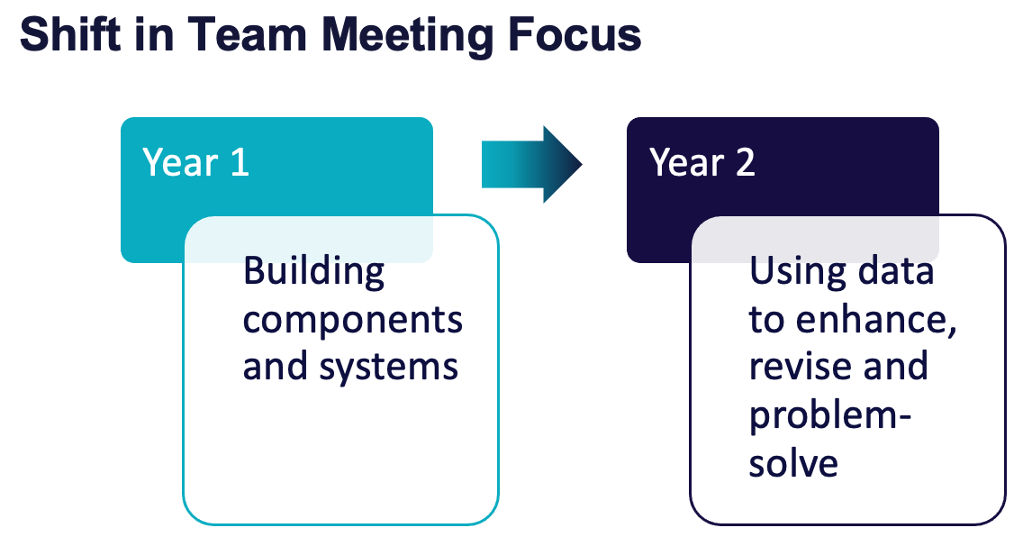

Essential Question: How do we use relevant data effectively and efficiently?
Year 1 Focus: Building components and systems
Year 2 Focus: Using data to enhance, revise and problem-solve

Ways to Establish and Strengthen Data Routines:
- Identify the RIGHT data (outcome data tied to goals; fidelity data tied to evaluation plan)
- Assess data INTEGRITY (Consider staff training & engagement, systems, response rates)
- Identify the RIGHT people (Who needs to see these data to inform decisions? (e.g., PBIS team, grade level teams, family groups, other committees?)
- Identify the RIGHT time & format (When/how often should these data be reviewed to inform decisions? What format will facilitate decision making?)

Activity: Strengthening Data Routines
Summary of Discussion
Identify how you will incorporate data routines into team meetings.

Plan for:
- Administration of school climate surveys for students, families, staff
- Regular review of student outcome data
- School-wide behavior
- Other (e.g. attendance)

Add items to your action plan as needed

Data-based Decision-making:

Precise Problems & Outcomes

Once data routines are established…
…use the data to guide decision-making!

Considering the Problem & Goal
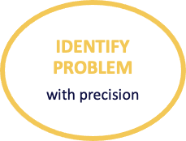 | Questions to Consider:  What is our current reality or big picture?  Is there a problem (red flag)?  What is the precise context & function of the problem?
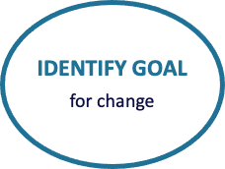 | Questions to Consider:  What do you want to change?  By when?  Where will the change happen (context or condition)?  How will it be measured?

Activity: Precise Problem & Outcome Statements
Summary of Discussion
As a team:

- Review your available data (e.g. behavior, school climate, attendance)
- Develop 1-2 precise problem statements
- Identify an observable, measurable goal for each precise problem statement

Add items to your action plan as needed.

Implementing & Monitoring a Solution
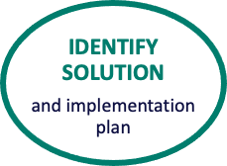 | Questions to Consider:  What is happening before the behavior (antecedent)  What is happening after the behavior to reinforce it (consequence)  Why the behavior is likely happening (function)  Then…  How can the behavior be prevented?  What can be taught?  How can the new behavior be reinforced?
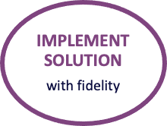 | Things to Remember:  Iterative process  Continuously review implementation  Modify or adapt in response to feedback from students, faculty, staff, and families
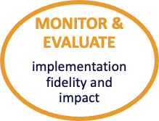 | Questions to Consider:  Is the solution being implemented as planned?  How well is it working?
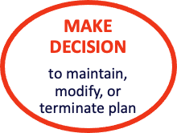 | The Team decides if the problem…  …improvement matches the goal  …improvement happened, but goal was not met  …did not improve  Then, decides to continue, adapt, or end the plan

Activity: Identify Solution, Implementation and Evaluation Plan
Summary of Discussion
As a team:

Identify an evidence-based, practical solution for your identified goal(s).

Then, decide how the solution will be implemented, monitored and evaluated.

Add items to your action plan as needed.

Classroom Practices
Evidence-based Practices to Create Positive Teaching and Learning Environments & Promote SEB Growth
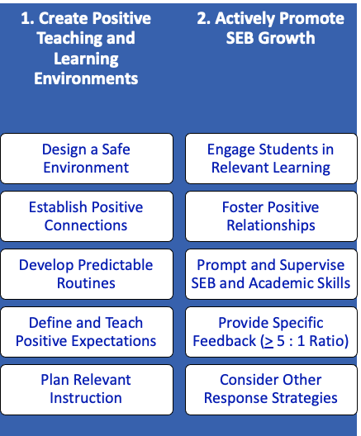
Source: Supporting and Responding to Students Social, Emotional, and Behavioral Needs (center on PBIS, 2022)

Activity: Promoting Positive, Proactive Classroom Practices with Staff
Summary of Discussion
As a team,

Plan how you will explicitly train staff in positive, proactive classroom practices.

Add items to your action plan.
needed.

Monitoring Fidelity
Essential Questions:
Did this actually happen?
How can we know?

Ways to Monitor Fidelity
Walkthroughs  Ex. Identify how many classrooms have a classroom matrix posted | Surveys  Ex. Educators self-assess their fidelity of teaching expectations | 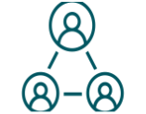  Team Reps  Ex. Team reps meet with their group and gather self-reported information

Activity: Monitor Fidelity
Summary of Discussion
As a team,

Consider how you can gather data on classroom educator fidelity of:
- aligning classroom expectations with schoolwide expectations
- posting classroom expectations
- explicit teaching of classroom expectations

Add items to your action plan

Family Engagement
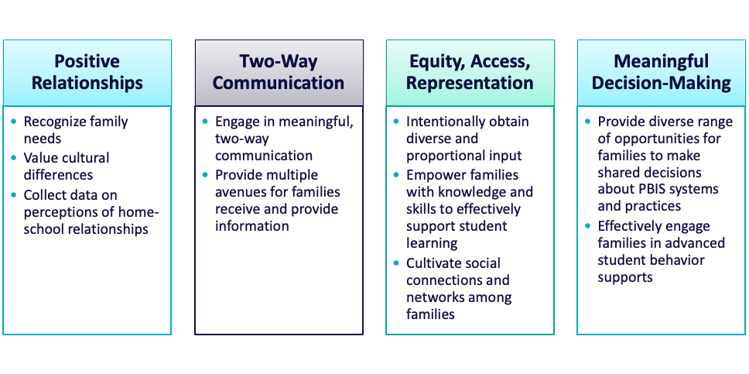

Activity: Family-School Practices Survey
Summary of Discussion
As a team:

Complete the Family-School Practices Survey

Add 2 to 3 items to your action plan based on priorities discussed while completing the survey.

Training Day 8 Activities
↓ DAY 8 ↓
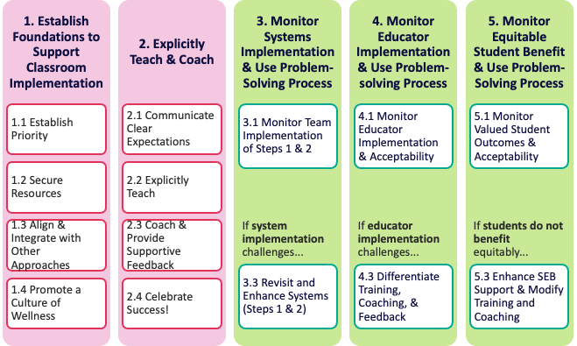

Sections:  - Establishing a Culture of Wellness for All  - Classroom Systems  - Equity Review | Outcomes:  - Enhance and adjust current features to promote wellness within Tier 1  - Complete Classroom Systems self-assessment  - Begin to develop support systems for classroom implementation  - Understand the role of equity within data review.  - Identify a goal and use the problem-solving framework to improve equity
Related Training Materials:  - NEPBIS Day 8 Training Slides | Additional Resources:  - Supporting and Responding to Educators’ Classroom PBIS Implementation Needs  - NEPBIS SWIS Alternative Tool  - SWIS Equity Report

Establishing a Culture of Wellness for All

What is Wellness?
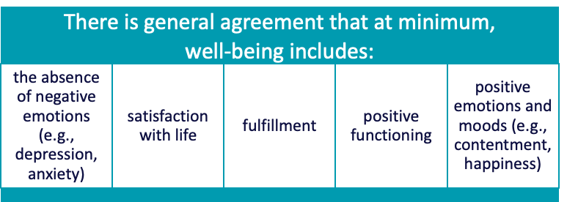

How do teams integrate wellness into Tier 1?
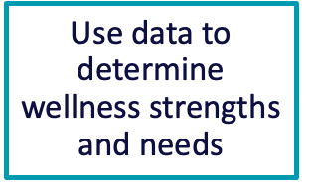 | 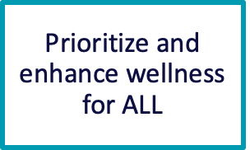 | 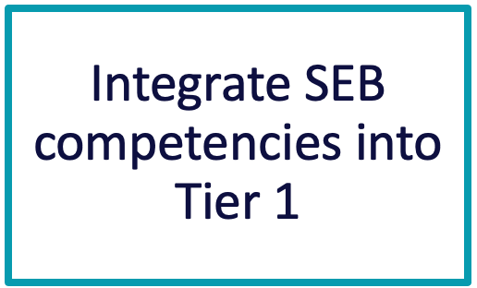
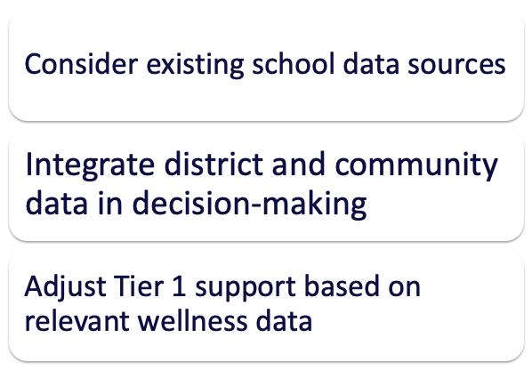 | 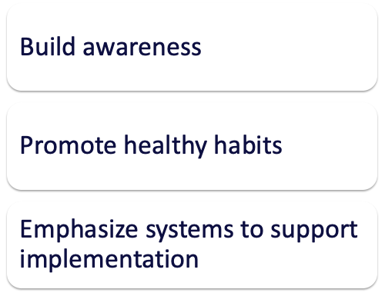 | 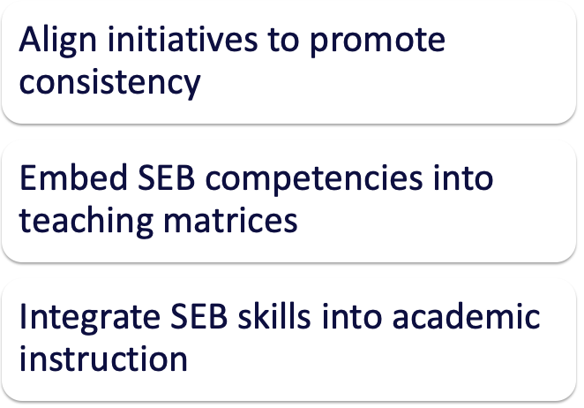

Activity: Supporting Student & Staff Wellness
Summary of Discussion
As a team, identify:
- What are you currently doing to support wellness for both students and staff?
- What data will you use to determine needs?
- How can wellness be prioritized and enhanced?
- How can social-emotional competencies be integrated in your Tier 1 supports?

Add to your action plan as needed.

Classroom Systems
Guiding question:
How do we support educators with use of evidence-based practices to support and respond to student behavior?

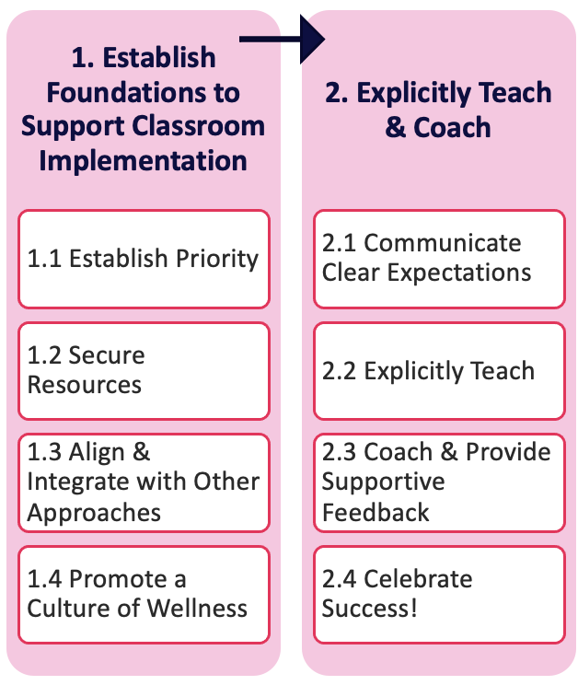

Activity: Classroom Fidelity Data Review 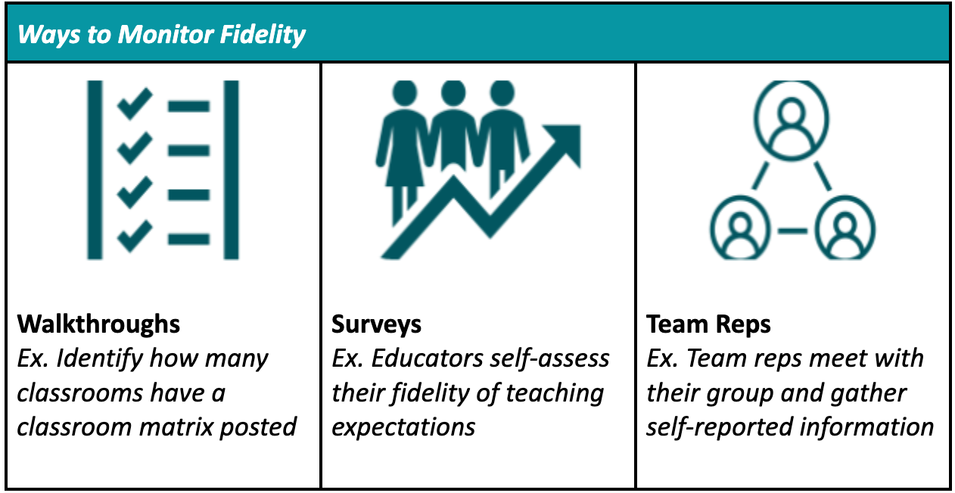
Summary of Discussion
As a team, review the data you gathered on classroom expectations fidelity.

- Were you able to gather the relevant data efficiently and accurately?
- What worked well?
- What can be enhanced?
- What did your team learn from the data?
- How does this inform your next action planning steps?

Supporting and Responding to Educators’ Classroom PBIS Implementation Needs
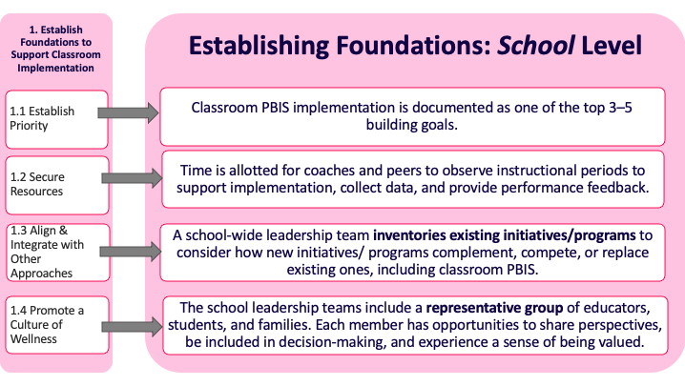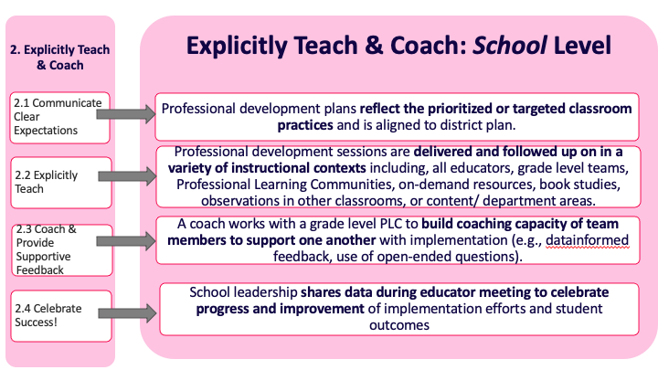

Activity: Classroom Systems Self-Assessment
- Complete the Classroom Systems Self-Assessment (Center on PBIS, 2023) questions below.
- Identify current implementation status of establishing foundations and explicit training and coaching features.
- Identify which features are a priority for action planning.
- Choose 1-2 high priority features to add to your action plan.
 |  | Self-assess Implementation |  |  | Priority for Action Planning
 |  | Fully | Partially | Not at all | Low | Medium | High
Establish foundations to support Classroom PBIS implementation (Table 1)
1.1 Collaboratively establish priority
1.2 Secure resources
1.3 Align and integrate with other initiatives
1.4 Promote a culture of wellness
Explicitly train and coach to support Classroom PBIS implementation (Table 2)
2.1 Communicate clear expectations
2.2 Provide explicit training
2.3 Offer coaching that includes supportive feedback
2.4 Celebrate success

Equity Review

Equity in Education is…
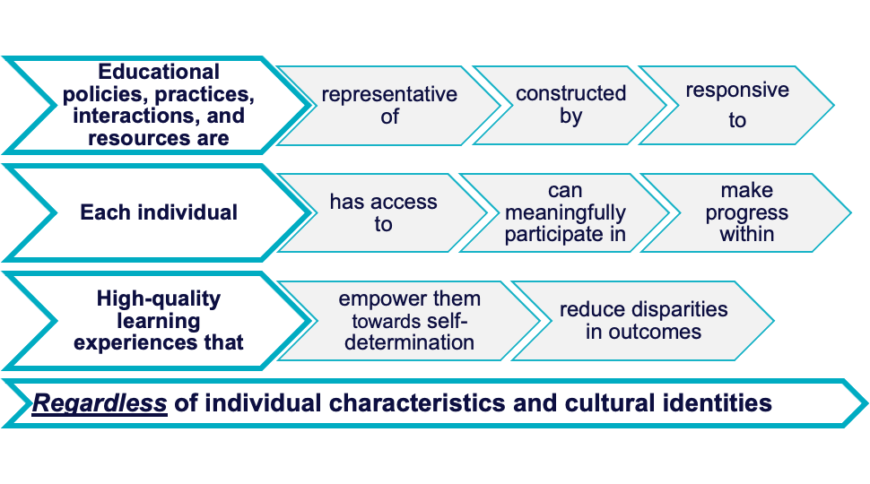
Equity Terms & Report Types
Disproportionality
a group’s representation in a particular category that exceeds expectations for that group, or differs substantially from the representation of others in that category.
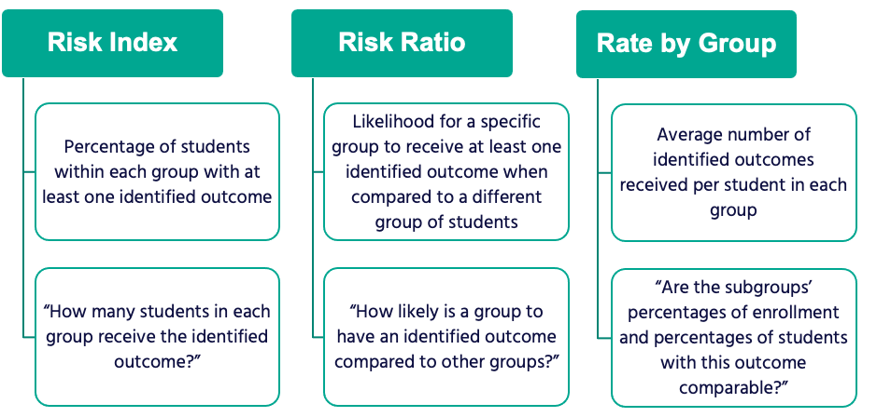

Guidelines for Equity Review
- Disaggregate data by a range of sub-groups and across varied outcomes
- Use evidence-based practices to reduce disproportionality
- Gather input from people who are impacted by the inequity
- Share the data with your school community
- Provide a welcoming, safe space for critical discussions
- Embed equity review into your data review routines
- Use your problem-solving framework to continuously improve your school’s environment

Activity: Equity Review 1
Summary of Discussion
As a team,

- Identify how equity is, or is not, currently promoted within your school
- Consider how you will support staff with understanding equity
- Decide on one area to examine data for equity
- Identify how your team will embed equity reviews into your meeting routines

Add to your action plan as needed.

Equity Review Driving Question:
Are school community members experiencing equitable outcomes in our school regardless of individual characteristics and identities? | …If not, apply the Problem Solving Framework
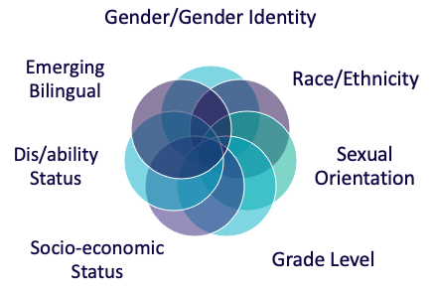 | 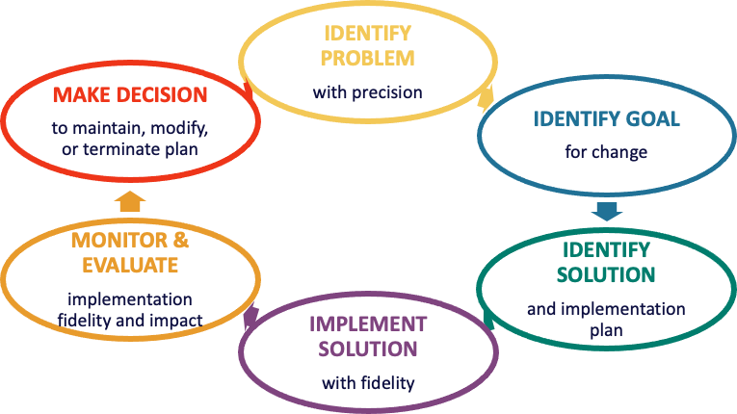

Activity: Equity Review 2
Summary of Discussion
As a team,  - Review either your referrals or school climate survey data.  - Identify 1 sub-group experiencing an inequitable outcome.  - Use your problem-solving framework to:  - Develop a precise problem statement  - Identify a goal  - Explore a possible solution  - Begin developing an implementation plan  Add to your action plan as needed. | Data used for review:  Subgroup identified:  Notes related to data analysis:

Training Day 9 Activities
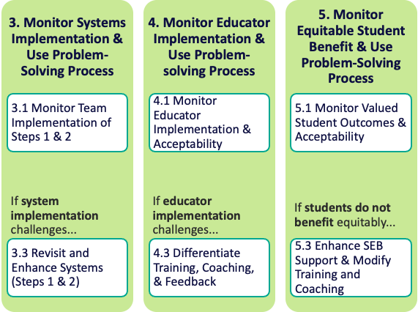

Sections:  - Preparing for Crises and Emergencies  - Classroom: Data  - Annual Evaluation | Outcomes:  - Plan to teach, prompt, and reinforce crisis expectations and routines  - Provide differentiated wellness support  - Complete Classroom Data self-assessment  - Consider how to use data to monitor classroom PBIS systems, educator implementation and student outcomes  - Develop a documented annual evaluation report
Related Training Materials:  - NEPBIS Day 9 Training Slides | Additional Resources:  - A School Guide for Returning to School During and After Crisis  - Supporting PBIS Implementation Through Phases of Crisis Recovery  - Tier 1 Annual Evaluation Report Template  - Tier 1 Annual Evaluation Report Sample

Preparing for Crises and Emergencies

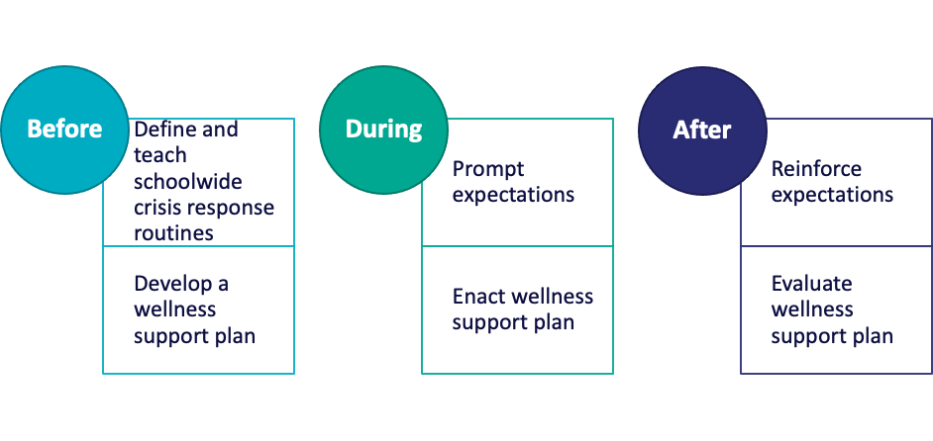

Using Your PBIS Framework When

Crises Occur
Key Messages:
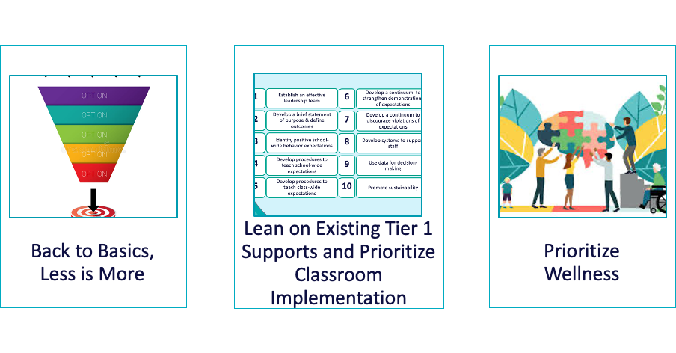
Guidelines for Preparing for Crisis and Emergencies
- Define, teach, prompt and reinforce crisis and emergency expectations and routines as explicitly as other schoolwide expectations and routines.
- Recognize that some staff and students will need additional support during practice drills.
- Develop a wellness support plan to proactively address staff and student needs.
- When a crisis occurs:
  - Go back to basics, remember less is more
  - Lean on your existing Tier 1 supports
  - Prioritize wellness

Activity: Crisis and Emergency Practice Routines
Summary of Discussion
As a team,

Draft school-wide expectations for crisis and emergency practice routines and a plan for teaching them explicitly.

Consider how you will identify those that will likely need additional support throughout practice routines.

Begin a wellness support plan to address staff and student needs.

Add to your action plan as needed.

Classroom: Data
Driving Question: How do we know if our classroom environments are positive, proactive, predictable and equitable?

Guidelines for Using Data to Support Classroom PBIS Implementation
Once systems are in place to support classroom PBIS implementation:
- monitor your systems implementation for fidelity and impact consistently
- monitor educator implementation and acceptability data regularly
- monitor student outcomes for impact, acceptability and equity continuously
- when challenges occur, use your continuous improvement process and seek input from staff, students, and families involved

Activity: Classroom Data
- Complete the Classroom Data Self-Assessment (Center on PBIS, 2023) questions below.
- Identify current implementation status of establishing monitoring systems implementation, educator implementation and equitable student benefit features.
- Identify which features are a priority for action planning.
- Choose 1-2 high priority features to add to your action plan.
 |  | Self-assess Implementation |  |  | Priority for Action Planning
 |  | Fully | Partially | Not at all | Low | Medium | High
Monitor systems implementation and use continuous improvement process to support classroom PBIS implementation (Table 3)
3.1 Monitor team implementation of steps 1 & 2 (Establishing benefit and explicit trianing/coaching)
3.2 Use continuous improvement process
3.3 If system implementation challenges, revisit and enhance systems (Steps 1 & 2)
Monitor educator implementation and use continuous improvement process to support classroom PBIS implementation (Table 4)
4.1 Monitor educator implementation and acceptability
4.2 Use continuous improvement process
4.3 If educator implementation challenges, differentiate training, coaching & feedback
Monitor equitable student benefit and use continuous improvement process (Table 5)
5.1 Monitor valued student outcomes and acceptability
5.2 Use continuous improvement process
5.3 If students do not benefit equitably, enhance SEB support and modify training & coaching

Annual Evaluation
Driving Questions
Are you implementing your framework with fidelity?
Is it having its intended impact?

Annual Evaluation Guidelines
- Evaluate and document your framework annually
- Use your existing data routines and identified outcomes
- Develop an annual report that identifies celebrations, areas to strengthen and action steps
- Share with your school community
- Gather feedback from staff, students and families about the annual report

Activity: Evaluation Data
Summary of Discussion
As a team,

Identify the data you will use for your annual evaluation
Consider how you will document, share and gather feedback on your evaluation

Add to your action plan as needed.

