ANNUAL PBIS EVALUATION REPORT (YEAR)
INSERT SCHOOL NAME HERE

tier 1 implementation FIDELITY
We have reached total xx% fidelity of implementation in Tier 1.

(Insert Scale TFI report here)

(Insert Subscale TFI report here)

OUTCOMES
We identified outcome goals for the year as:
- X
- X
- X
The data below demonstrates our progress towards our identified outcome goals.
(Insert appropriate charts/graphs here to match your identified outcomes. Consider referral, school climate, staff self-assessment survey, and/or attendance data. Graphs and charts identified below are widely used however revise to meet the context of your school and outcome goals. )

Our referral data shows…
(Insert any of the SWIS dashboard charts and/or the triangle graph)

Students in grades x-x took the Georgia School Climate Survey in (month). Our overall school climate score is xxx out of 4 where 1=never and 4=always. (#) of our students, xxx% of our total student population, completed the survey.
(Show Score by Item graph) 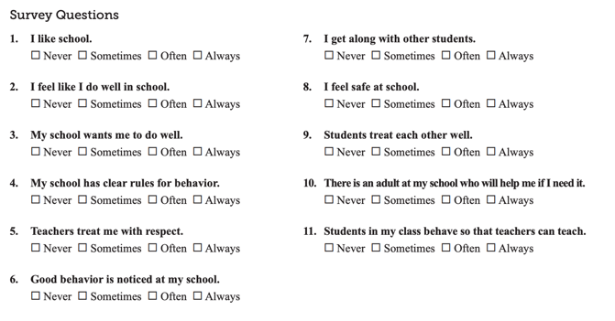

Families also completed a school climate survey in (month). (#) people responded. Assuming this represents (#) different families, xxx% of our families completed the survey. Our overall score was xx out of 4 on a scale where 1=never and 4=always.
(Show Mean Scores by Subscale graph)

Staff were asked to complete a self-assessment survey focused on our behavior support framework. xx% of our staff completed this survey in (month). The green graph represents staff perception of what is in place and the blue graph represents how high of a priority each element is for improvement.

(Show School-wide Current Status and School-wide Improvement Priority graphs)

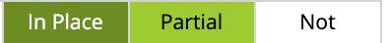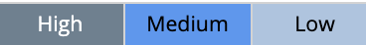

Celebrations:
- Xxx
- Xxx
- Xxx
Areas to strengthen:
- Xxx
- Xxx
Action step(s) we plan to take:
- Xxx
- Xxx

Overview
OVERVIEW(Use this space to acknowledge support provided, request more participation, offer ways for stakeholder input, share important messaging, etc.)

