Name: _______________________________ Teacher: ______________ Grade: ________ Date: ___________ Time: ________ Location: _________
My Think Sheet
1. How are you feeling? Circle one:  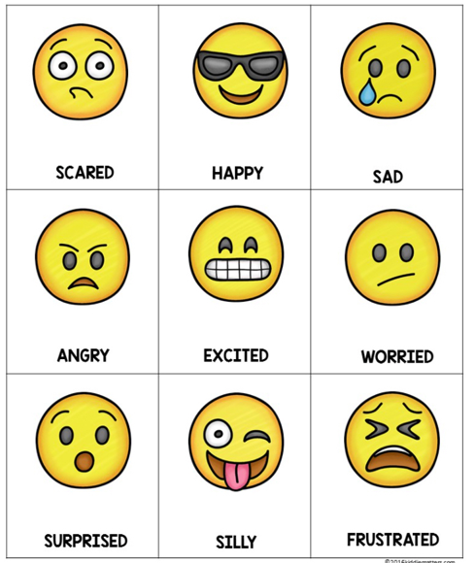 | Use Circle Breathing if you need to:  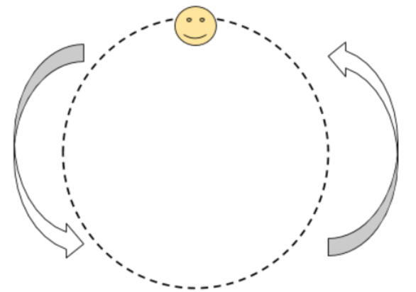
2. What was the expected behavior?
Draw a picture:
(Staff member can also write for the student)
3. What was your behavior?
Draw a picture:
(Staff member can also write for the student)

Are you feeling calm and ready to Respect yourself, others, and our School?
Circle when you are ready: Yes

Optional debrief with teacher: How did your behavior affect others around you?

For Staff Only: Location:_____________ Time of Day: ____________ # of Think Time Forms Completed: ______
Unexpected Behavior: | Possible Motivation:
□ Disrespect | □ Avoid Adult(s) |  | □ Obtain Adult(s) Attention
□ Defiance/Insubord./Non-comp. | □ Avoid Peer(s) |  | □ Obtain Items/Activities
□ Disruption | □ Avoid Task |  | □ Obtain Peer Attention
Others Involved: ________________________________________________________________________________

Notes: ________________________________________________________________________________________________________________________________________________________________________________________________________________________________________________________________________________________

