ANNUAL PBIS EVALUATION REPORT (YEAR)
INSERT SCHOOL NAME HERE

tier ONE implementation
We have reached total xx% fidelity of implementation in Tier 1.

(Insert Scale TFI report here)

(Insert Subscale TFI report here)

tier one OUTCOMES
In addition, we looked at stakeholder outcome data to determine if we are achieving our desired outcomes.
(Insert appropriate charts/graphs here to match your identified outcomes. Consider office discipline, school climate, staff self-assessment survey, and/or attendance data. Graphs and charts identified below are widely used however, please consider revising to meet the context of your school and outcome goals.)
Our discipline data shows…
(Insert any of the SWIS dashboard charts and/or the triangle graph)

Students in grades x-x took the Georgia School Climate Survey in (month). Our overall school climate score is xxx out of 4 where 0=never and 4=always. (#) of our students, xxx% of our total student population, completed the survey.
(Show Score by Item graph) 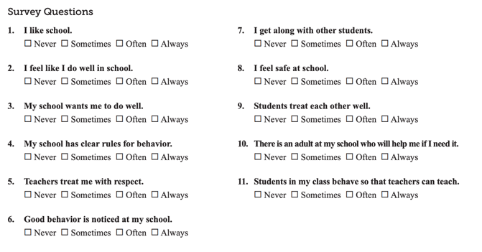

Families also completed a school climate survey in (month). (#) people responded. Assuming this represents (#) different families, xxx% of our families completed the survey. Our overall score was xx out of 4 on a scale where 0=never and 4=always.
(Show Mean Scores by Subscale graph)

Staff were asked to complete a self-assessment survey focused on our behavior support framework. xx% of our staff completed this survey in (month). The green graph represents staff perception of what is in place and the blue graph represents how high of a priority each element is for improvement.

(Show School-wide Current Status and School-wide Improvement Priority graphs)

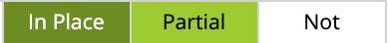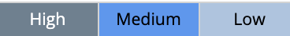
Our attendance data shows…
(Show attendance data graph)
Celebrations:
- Xxx
- Xxx
- Xxx
Areas to strengthen:
- Xxx
- Xxx
Action step(s) we plan to take:
- Xxx
- Xxx

OVERVIEW
(Use this space to acknowledge support provided, request more participation, offer ways for stakeholder input, share important messaging, etc.)

