ANNUAL PBIS EVALUATION REPORT 2020-2021
CENTRAL COMMUNITY SCHOOL

tier ONE implementation
We have reached total 67% fidelity of implementation in Tier 1. Teams and evaluation features are strong. Implementation features are lower than we want them to be.

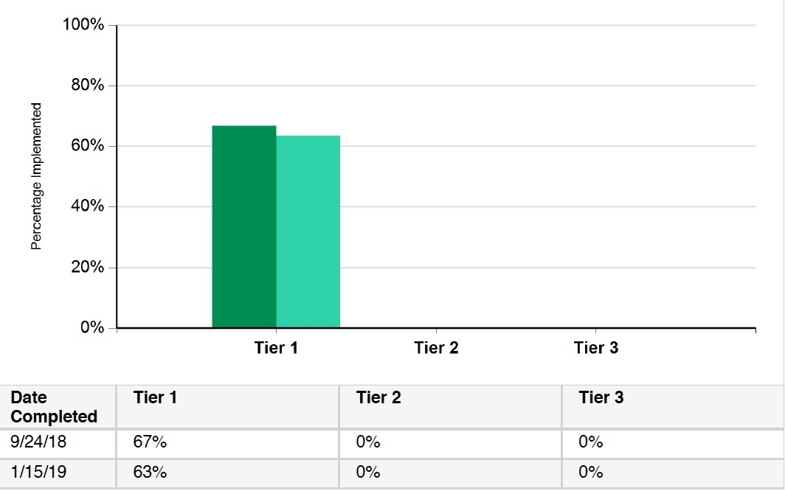
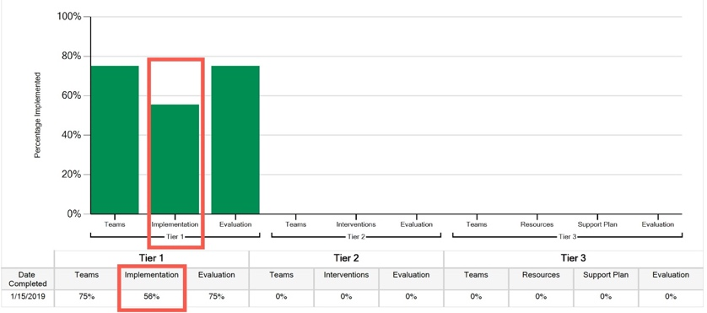

tier one OUTCOMES
In addition, we looked at student attendance data to determine if we are achieving our desired outcomes. Last year we had 16.9% of students absent more than 10% of the school year. This year we had 17.3%. While not a large difference, there are now 7.2% of students absent 20% of the year compared to 4.9% of students last year.

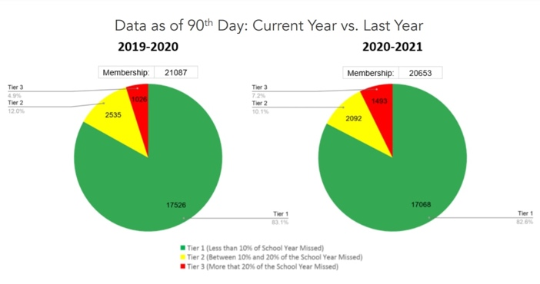
Celebrations:
- The threshold for implementation fidelity is 70% and we are really close to meeting it!
- Our students attending school >90% of the time remained relatively consistent across last year and this year.
Areas to strengthen:
- Our Tier 1 implementation score was lower than other areas. Our deeper review showed that we still need to formalize the process for consistent staff responses to student behavior (both acknowledging appropriate behavior and discouraging inappropriate behavior)
- Reducing number of students with more than 20% of school year absences
Action step(s) we plan to take:
- Add a PBIS section to the staff handbook that includes our school-wide acknowledgement procedures, office vs. staff-managed behavior chart, flowchart for responding to behavior, and protocols for reporting student behavior. Provide PD to all staff during school opening days this fall.
- Explore our Tier 2 systems and practices for attendance support and check fidelity of existing systems.

OVERVIEW

We have had a terrific year and our data review shows it! The PBIS leadership team would like to thank everyone for their ongoing feedback and consistent implementation of the practices that make our school safe, welcoming and effective. We look forward another year of growth ahead! We are looking to expand our team to include more family members so please email Grace Kelly at gkelly@school.net if you would like to be a part of this process.

