CICO-SWIS
Point Card Examples

CICO-SWIS Point Card Requirements:
- Standard for all students
- Three point Scale (e.g., 0, 1, 2)
- 3-5 School-wide Expectations
- Up to 10 Check in times

Name: ____________________________ Points Goal:
Date: _____________________________ Points Earned:
 | = 2 Points | 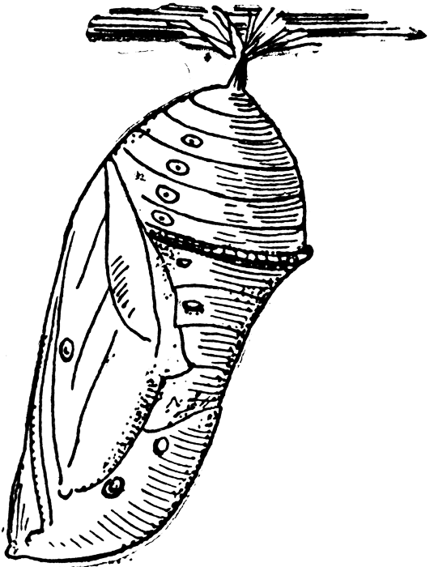 | = 1 Point | 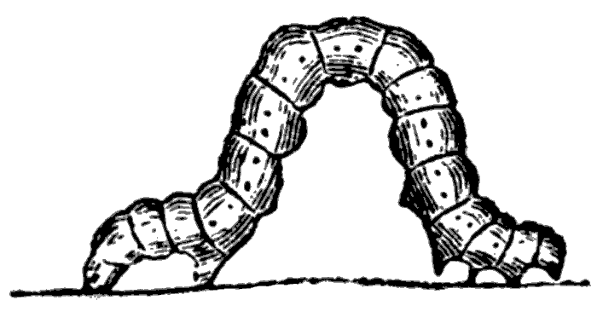 | = 0 Points

Expectation | Period 1 | Period 2 | Period 3 | Period 4
Safe
Respectful
Responsible
Staff
Initials
Total
Points

Goal Reached? Yes No
Teacher Signature: ___________________________________________________________________
Comments: ________________________________________________________________________

Early Childhood Example

Elementary School Examples:

HAWK Report – Helping A Winning Kid

Name: Points received
Date:
Daily Goal _____ Daily goal reached? Yes No

GOALS | Period 1 | Period 2 | Period 3 | Period 4 | Period 5 | Period 6
Be Safe | 0 1 2 | 0 1 2 | 0 1 2 | 0 1 2 | 0 1 2 | 0 1 2
Be Respectful | 0 1 2 | 0 1 2 | 0 1 2 | 0 1 2 | 0 1 2 | 0 1 2
Be Responsible | 0 1 2 | 0 1 2 | 0 1 2 | 0 1 2 | 0 1 2 | 0 1 2
TOTAL

H.U.G.
(Hello, Update, Goodbye)

Name: __________________________________ Date: _______________________

Please indicate whether the student has met the goal during the time period indicated.
Meets: ☺ (2 points) So, so: 😐 (1 point) Doesn’t meet: ☹ (0 points)
Goals | AM to Lunch | Lunch Recess | PM
Be Safe | ☺ 😐 ☹ | ☺ 😐 ☹ | ☺ 😐 ☹
Be Kind | ☺ 😐 ☹ | ☺ 😐 ☹ | ☺ 😐 ☹
Be Responsible | ☺ 😐 ☹ | ☺ 😐 ☹ | ☺ 😐 ☹
Total Points
Teacher Initials

HUG Daily Goal _____/18 HUG Daily Score _____/18
Teacher Comments: Please state briefly any specific behaviors or achievements that demonstrate the student’s progress.

Parent’s Signature and Comments:

School Name
Check In Check Out (or other name of program i.e. “PAWS”)
Student name:____________________________ CICO mentor:________________________ Date:________________

 | Expectation #1 | Expectation #2 | Expectation #3 | Total Points | Teacher Initials
Period 1 | 0 1 2 | 0 1 2 | 0 1 2
Period 2 | 0 1 2 | 0 1 2 | 0 1 2
Period 3 | 0 1 2 | 0 1 2 | 0 1 2
Period 4 | 0 1 2 | 0 1 2 | 0 1 2
Period 5 | 0 1 2 | 0 1 2 | 0 1 2
Period 6 | 0 1 2 | 0 1 2 | 0 1 2
Period 7 | 0 1 2 | 0 1 2 | 0 1 2
Period 8 | 0 1 2 | 0 1 2 | 0 1 2
Key:
2 points | Behavior was appropriate; student managed his/her own behavior.
1 point | Behavior was somewhat appropriate; student needed one reminder.
0 points | Behavior was inappropriate; student continued problem behavior after reminder(s).

Middle School Examples:

Daily Progress Report

Name _____________________ Rating Scale Points Possible _______
Date______________ _________ 2=Great Goal to meet_______
1=Sort of Points received_____
0=Try Again Goal Met Yes No

Goal | Period 1 | Period 2 | Period 3 | Period 4 | Period 5 | Period 6 | Period 7
Be Safe | 0 1 2 | 0 1 2 | 0 1 2 | 0 1 2 | 0 1 2 | 0 1 2 | 0 1 2
Be Responsible | 0 1 2 | 0 1 2 | 0 1 2 | 0 1 2 | 0 1 2 | 0 1 2 | 0 1 2
Be Respectful | 0 1 2 | 0 1 2 | 0 1 2 | 0 1 2 | 0 1 2 | 0 1 2 | 0 1 2
TOTAL

Comments

Parent/Guardian Signature

Middle School
Check & Connect Card

Name: Points received
Date:
Daily Goal _____ Daily goal reached? Yes No

Goal/  Period | Be Responsible | Be Respectful | Do Your Personal Best
Period 1: | 0 1 2 | 0 1 2 | 0 1 2
Period 2: | 0 1 2 | 0 1 2 | 0 1 2
Period 3: | 0 1 2 | 0 1 2 | 0 1 2
Period 4: | 0 1 2 | 0 1 2 | 0 1 2
Period 5: | 0 1 2 | 0 1 2 | 0 1 2
Period 6: | 0 1 2 | 0 1 2 | 0 1 2
High School Examples:
Oregon High School
Name _____________________________________ Points: _____________
CLASS | Perseverance | Respect | Integrity | Discipline | Excellence | Teacher initial
1st period  _________ | 0 1 2 | 0 1 2 | 0 1 2 | 0 1 2 | 0 1 2
2nd period  _________ | 0 1 2 | 0 1 2 | 0 1 2 | 0 1 2 | 0 1 2
3rd period  __________ | 0 1 2 | 0 1 2 | 0 1 2 | 0 1 2 | 0 1 2
4th period  _________ | 0 1 2 | 0 1 2 | 0 1 2 | 0 1 2 | 0 1 2

Parent / Guardian signature_______________________________
Comments? Questions? _____________________________________________________________________________________
California High School
Name _____________________________________ Points: _____________

Goals | 1/5 | 2/6 | 3/7 | 4/8 | Total  Points
Be Respectful | 0 1 2 | 0 1 2 | 0 1 2 | 0 1 2
Be Responsible | 0 1 2 | 0 1 2 | 0 1 2 | 0 1 2
Follow Directions | 0 1 2 | 0 1 2 | 0 1 2 | 0 1 2
Be There & Be Ready | 0 1 2 | 0 1 2 | 0 1 2 | 0 1 2

Comments: ____________________________________________________________________________________
Sample High School Daily Progress Report
Check-In/Check-Out Form - Daily Progress Report
Name: __LaVonne Walker______ Date: __10/15/15_________________
Teachers: Please indicate Yes (2), So-So (1), or No (0) regarding student’s achievement for the following goals today.
Daily Goal: % Daily Score: %
Goals | Period 1/5 | Period 2/6 | Period 3/7 | Period 4/8
Be There | 2 | 2 | 2 | 1
Be Ready | 1 | 1 | 1 | 2
Best Effort | 2 | 1 | 2 | 1
Homework Complete | 1 | 0 | 1 | 0

Teacher comments: Please state briefly any specific behaviors or achievements that demonstrate the student’s progress.

Period 1/5 Behavior is improving!
Period 2/6
Period 3/7 Thanks for your great focus today _____________
Period 4/8

