Coming Soon 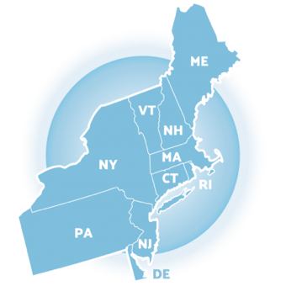
Georgia School Climate Surveys
2020 – 2021
Given the significant recent disruptions to school environments, school and districts may need to expand the data used to guide PBIS implementation efforts. Office discipline referrals, attendance, and even academic performance may become more difficult to collect and interpret as school move between learning modes. Additionally, the impacts of these disruptions on individual teachers and students and specific groups is unknown making it essential that school collect and use robust data related to student and teacher perceptions of school climate. These data sources can be used to ensure students and teachers are feeling connected and engaged in their learning environments despite the disruptions.

General Recommendations:
  - Delay initial survey administration until new fall routines are established (Nov-Dec)
  - Consider administering 2 times during the academic year late fall/spring
  - Use the extended survey (36 item survey) over the brief due to the added importance of understanding different aspects of school climate this year

Accessing the Survey:
  - The 36-item secondary student survey student will be available soon at
pbisapps.org
  - A modified version of the student and personnel survey for AY 2020-2021 will be available soon at nepbis.org.
    - The modified version offers:
      - A brief introductory statement clarifying that students should consider their feelings related to all school related activities including remote, hybrid, or in person events when taking the survey
      - Added introductory questions to capture information about learning or teaching mode (i.e., remote, hybrid, in person), health and safety across settings, technology access, and peer interactions
      - All standard items with the use of skip logic to remove questions related to the physical environment for students and personnel that indicate they are fully remote.

