Bob Putnam
May Institute
National Technical Assistance Center
for PBIS

PBIS 101: Handout
Activity 1 Resource Mapping
What tier 3, specialized individualized, practices do we have in place for students who don’t respond to tier 2 practices?
-
-
-
-
-
-
-
-
-
-
(Place a checkmark next to those that are evidence based)
What tier 2, specialized group, practices do we have in place for students who don’t respond to tier 1 practices?
-
-
-
-
-
-
-
-
-
-
(Place a checkmark next to those that are evidence based)
What tier 1, schoolwide, practices do we have in place to support all students and staff?
-
-
-
-
-
-
--
(Place a checkmark next to those that are research [evidence] based)
~5%
~15%
~80% of Students

Tiered Resource Map

Activity 2 Systems, Practices & Data

What DATA are we gathering relative to our practices and our systems to support decision making?
-
-
-
-
-
On what social and academic OUTCOMES are we focused?
-
-
-
-
-
-
-

OUTCOMES

DATA
SYSTEMS

What PRACTICES do we have in place? (Reference tiered resource map)
-
-
-
-
-
-
What SYSTEMS do we have in place to support our practices?
-
-
-
-
-
-
-
PRACTICES

Activity 3 Teaching Matrix

Example Teaching Matrix for G. Ikuma School-Wide Behavioral Expectations

CLASSROOM

LUNCHROOM

BUS

HALLWAY

PLAYGROUND

Respect Others

Use inside voice

Raise hand to answer/talk

Eat your own food

Leave space for others to sit

Stay in your seat

Use inside voice

Stay to the right

Keep moving

Wait your turn

Review game rules

Respect Property

Recycle paper

Put writing tools inside desk

Return trays

Use own napkin

Keep feet on the floor

Walk on sidewalks

Put trash in cans

Close doors slowly

At bell return equipment

Use equipment as designed

Respect Yourself

Do your best

Ask

Wash your hands

Eat healthy foods

Be at stop on time

Sit up straight

Use your words

Know where you’re going

Have a plan

Look before you act

Blank Teaching Matrix

Activity 4 Lesson Planning
SUPPORT Social Skill Lesson Plan (Sample)

NAME OF EXPECTATION (RULE)
Be Respectful
ROUTINE
Classroom
OPERATIONAL DEFINITION OF EXPECTED BEHAVIOR WITHIN SPECIFIC ROUTINE
Students show respect in the classroom by raising their hands before speaking, encouraging and allowing peers to participate, and accepting feedback.

CLEARLY STATE BEHAVIORAL TEACHING OBJECTIVE(S)
Include 4 parts: learner(s), behavior(s), condition(s), and criteria
- Immediately following instruction, students will be able to (a) describe what respectful classroom behavior “looks like” and (b) correctly depict a positive example of respectful classroom behavior (in a skit) with 95% accuracy.
- Following instruction, during five sampled teacher directed activities, students will raise their hands and wait to be called to ask or answer a question on an average of 90% of opportunities.
- Following instruction, during five sampled group activities, students will encourage and allow peers to participate (as evidenced by all students contributing to discussion and group outcomes) across 85% of opportunities.
- Following instruction, when staff members present feedback, students will use calm language to thank the staff and ask questions on 80% of opportunities across 5 days.

LIST ALL MATERIALS REQUIRED TO TEACH THE LESSON
- A script for role plays for three students to model respectful classroom behavior
- Two response cards for each student, one with a + written on it and one with a – written on it
- A blank script for each student that prompts them to write the definition of respectful classroom behavior on the front and develop a skit to illustrate respectful classroom behavior inside
- Data collection sheets to monitor and evaluate student behavior following instruction

POSITIVE TEACHING EXAMPLES | NEGATIVE TEACHING EXAMPLES
- When a teacher is sharing information, Jorge quietly raises his hand and waits for the teacher to call on him before asking a relevant question. | - A teacher is delivering a lesson, and Jen stands up and shouts out, “I don’t get it.” When the teacher says, “Jen raise your hand if you have a question,” Jen screams louder.
- During a group activity, Jessica asks her peers what they think about her suggestion. When one peer doesn’t respond, she specifically asks that peer for feedback. | - Toby is assigned to a group with three classmates. He immediately shouts that he doesn’t want Brian in his group. When Brian sits down, Toby refuses to work with Brian.
- Jeff’s teacher tells him that his paper was well organized, but he needs to go back and correct spelling errors. Jeff says thank you, gets a dictionary, and starts working. | - Teresa’s teacher asks her to correct a math problem on her homework assignment. Teresa rolls her eyes and throws her paper away as she walks back to her desk.
- When Bobbi is reminded to raise her hand instead of talking out, she calmly raises her hand and waits to be called on to share her response. | - When the teacher asks Diane to walk slowly on her way to line up, Diane continues to walk very quickly (fast enough that she’s almost jogging) to the front of the line.
- When the teacher explains the roles that each group member may play, Marco listens quietly. When she joins her peers in the group, she asks who wants to play which role in the group and engages her peers in a conversation to choose roles. | - As the teacher is giving instructions for group work, Charles is looking around the room and making eye contact with peers he wants in his group. When they sit down, he doesn’t know what roles each person should take, but he tells everyone, “I’m the leader.”

LESSON ACTIVITIES
MODEL
(Indicate how you will demonstrate rule following behavior within the indicated routine)
Before teaching the lesson, the teacher will coach three students who have positive social status to engage in three brief role plays that demonstrate respectful classroom behavior during three classroom activities: teacher directed instruction (i.e., raising hand to ask a question), during group work (i.e., asking all peers for their opinion), and when accepting feedback (i.e., saying thank you).
LEAD
(Indicate how you will provide guided practice)
The teacher will read and briefly act out each positive and negative example. All students will be asked to identify whether the example is positive or negative (by holding up a response card with a + or a – written on it). If the example is positive, individual students will be asked to identify how the example illustrated respectful classroom behavior. If the example is negative, the students will be asked to state how the student should have behaved in that situation.
TEST
(Indicate how you will check for the understanding of each student)
Each student will be asked to write a brief skit that demonstrates respectful classroom behavior. Then, students will be given a blank script booklet that prompts them to write the definition of respectful classroom behavior on the front and then write the script for the skit inside. The teacher will review the scripts and choose the best skits for the class to act out the following day during a review session.

FOLLOW UP ACTIVITIES (DURING AND AFTER THE LESSON)
PROMPTING EXPECTED BEHAVIOR
- Before each classroom activity, the teacher will provide a specific verbal prompt about how students can show respect during that activity (e.g., before teacher directed instruction, the teacher will say, “To show respect, remember to raise your hand to ask or answer a question.”)
- Rules will also be posted within the classroom (a visual prompt).
REINFORCING APPROPRIATE BEHAVIOR
- When a student successfully demonstrates respectful classroom behavior, the teacher will provide specific and contingent praise (e.g., the teacher may say, “Thank you for showing respect by raising your hand.”)
- Also, for each specified period of time students demonstrate respectful classroom behavior, students will earn points toward their class-wide token economy.
CORRECTING INAPPROPRIATE BEHAVIOR
- If a student does not demonstrate respect, the teacher will provide an error correction (e.g., “Before you share, please raise your hand and wait for me to call on you. Try again.”)
- If a student continues to make the same behavioral error, the teacher will provide additional instruction in how to demonstrate respect.
MONITORING/SUPERVISING STUDENT BEHAVIOR
- The classroom teacher and staff will actively supervise students across classroom activities. They will take data to determine if students are meeting behavioral objectives.
  - For a period of five days following the lesson, the teacher will take data during a sample of teacher directed activities (by making a tally next to each student who raises his/her hand and calls out) to determine if students raise their hand on 90% of opportunities.
  - For five days following instruction, the teacher will take data during a sample of group activities and note which students participate (and provide specific feedback to students who are encouraging their peers to participate) to determine if all students are participating during 85% of opportunities.
  - For five days following instruction, the teacher will track how students respond each time they are presented with feedback to determine if students accept feedback appropriately (saying thank you and calmly asking questions) on 80% of opportunities.
- If needed, the teacher will assign staff to posts in the classroom and map out walking paths to ensure that staff are moving around, scanning the environment, and interacting with students (the three behaviors involved in active supervision).
COLLECTING AND EVALUATING STUDENT DATA
Data will be summarized across days and students. If students meet criteria specified in instructional objectives (as described in the previous section), the teacher will continue to actively supervise students and reinforce respectful behavior. If students do not meet criteria, the teacher will re-teach the lesson using different examples and increase reinforcement for respectful behavior.

Social Skill Lesson Plan

Name of Expectation (Rule)

Routine

Operational Definition of Expected Behavior Within Specific Routine

Clearly Stated Behavioral Teaching Objective
learner, behavior, conditions, criteria)
Conditions:
Learner:
Behavior:
Criteria:

List All Materials Required to Teach Lesson

Teaching Examples
Positive Examples | Negative Examples

Lesson Activities
Model
(Demonstrating expected behavior within indicated routine)
Lead
(Prompting and guided practice)
Test
(Checking for understanding for each student)

Activity 5 Data Based Decision Making
Sample SWIS Data

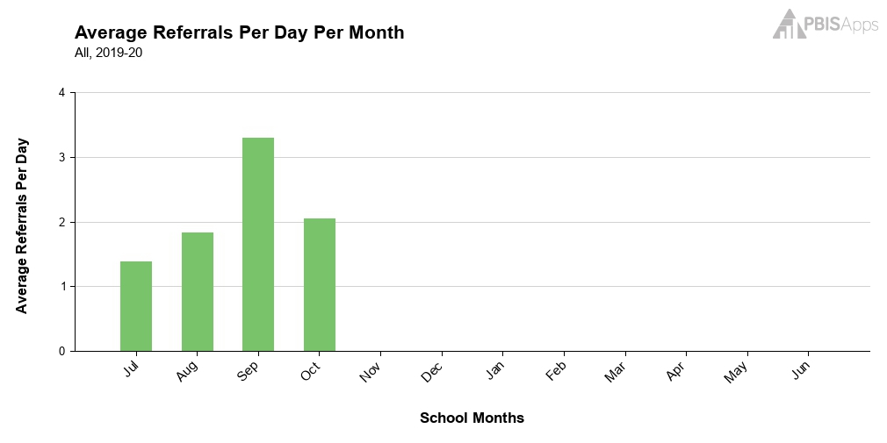

What month has the least number of referrals?

What month has the greatest number of referrals?

Is the trend of the referrals going up or down?

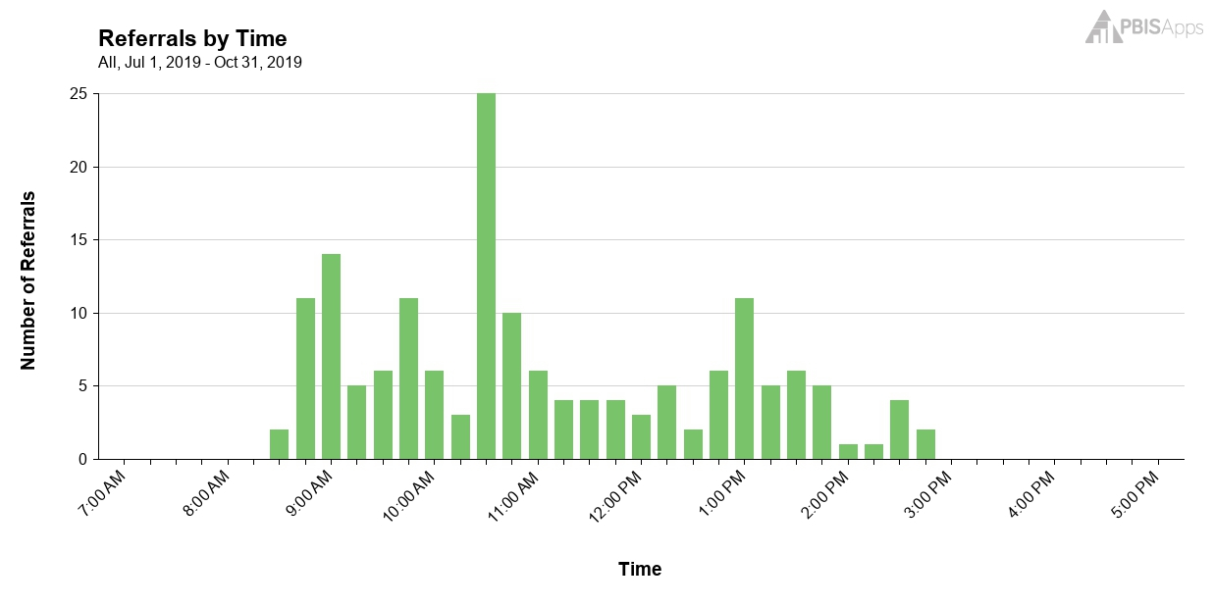 What times have the least number of referrals?

What times have the greatest number of referrals?

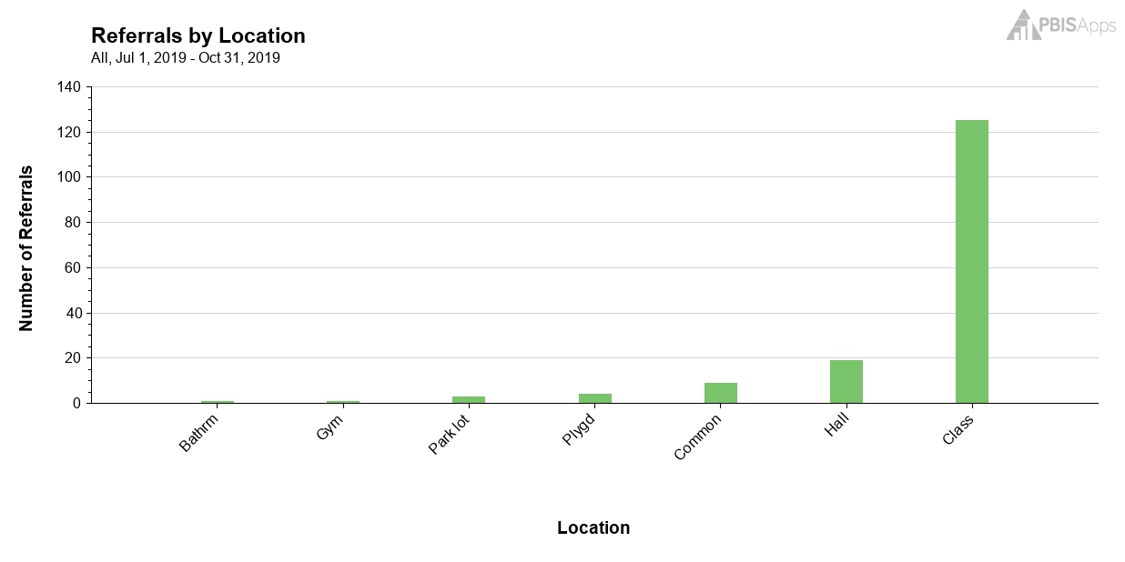
What location has the least number of referrals?

What location has the greatest number of referrals?

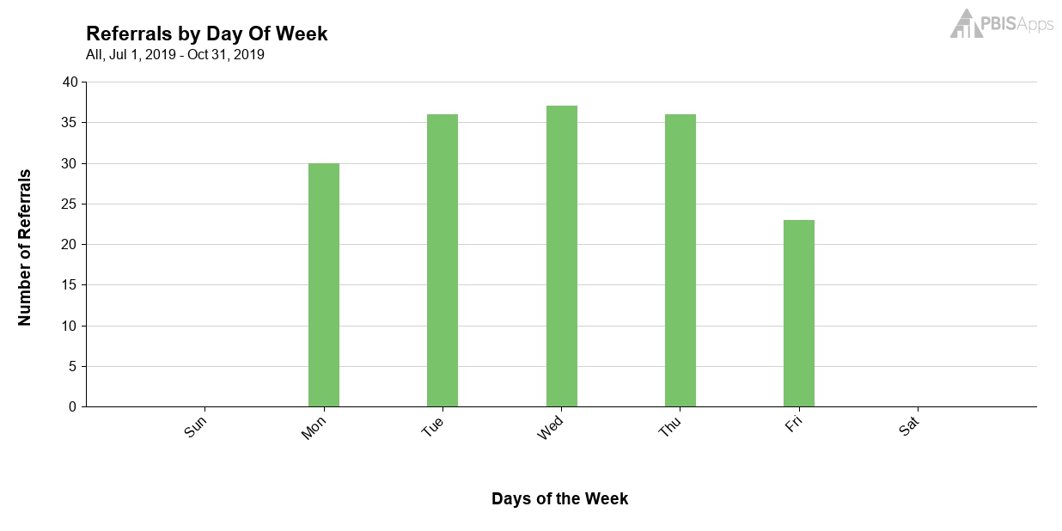

What day has the least number of referrals?

What day has the greatest number of referrals?

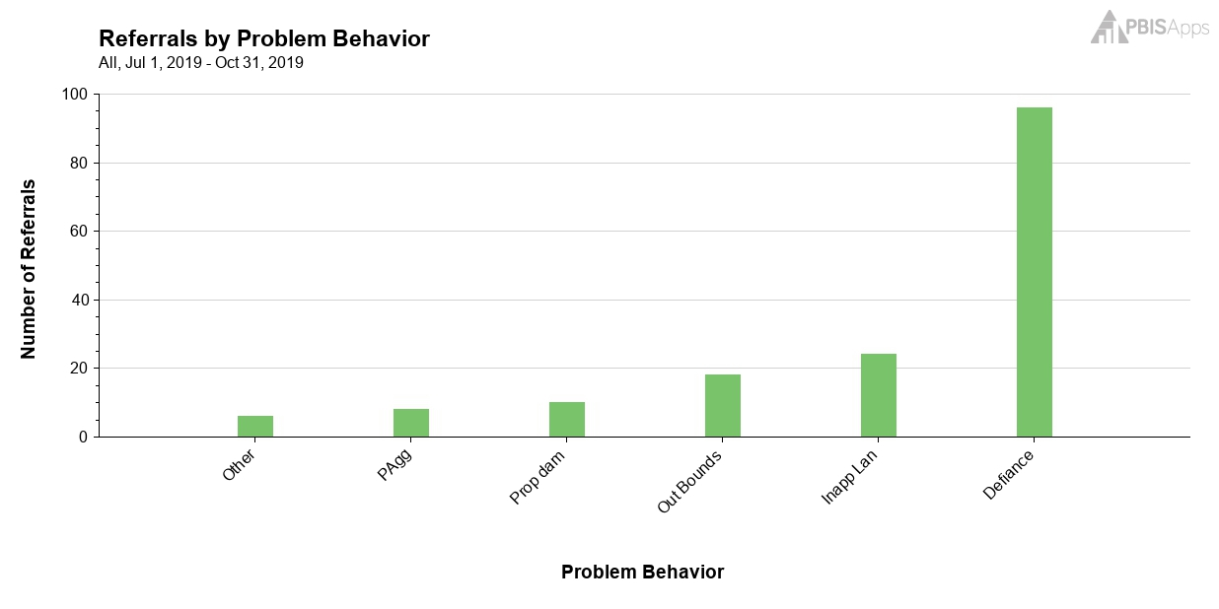
Which behaviors have the greatest number of referrals?

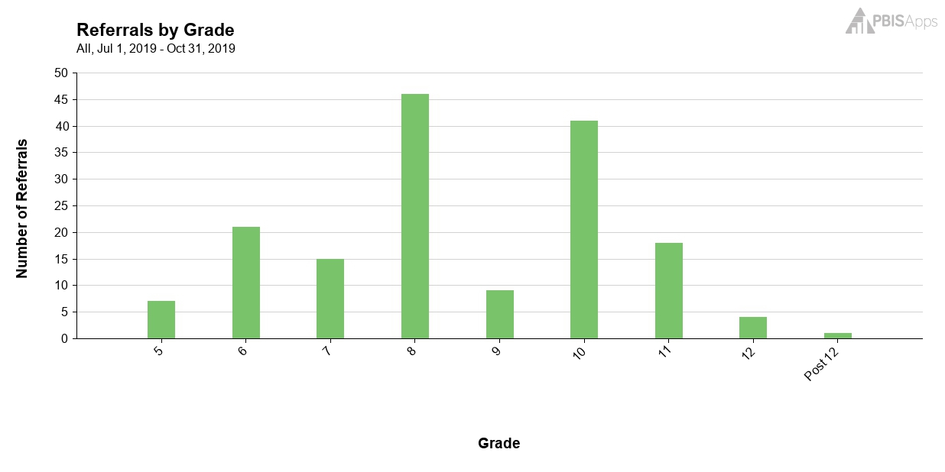
Which grades have the greatest number of referrals?

