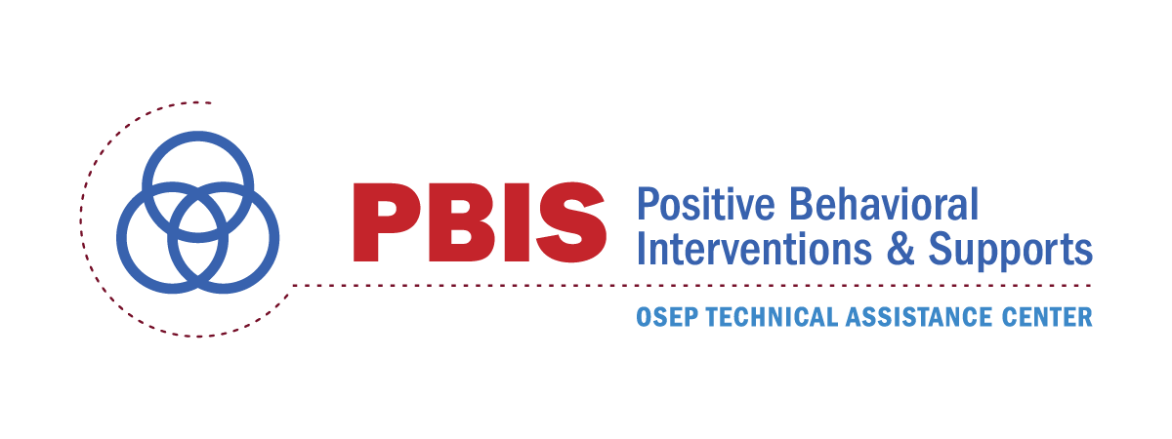
Positive Behavioral Interventions and Supports
Implementation Blueprint:

Part 2 - Self-Assessment & Action Planning

Technical Assistance Center on Positive Behavioral Interventions and Supports

U. S. Department of Education, Office of Special Education Programs

Version 2017 May 15

STATUS | POLICY AND SYSTEMS ALIGNMENT | ACTIONS
IP PP NP | - PBIS vision statement (and clear rationale) supporting importance of school climate (and how PBIS can improve both school climate and academic achievement) is developed and endorsed by lead state/district/school administrators.
IP PP NP | - PBIS vision statement is articulated into observable, measurable, specific, and actionable long-term outcomes.
IP PP NP | - PBIS implementation is included in organizational policy and procedural guidelines.
IP PP NP | - Policy, technical briefs, and procedural guides are posted and distributed at least annually.
IP PP NP | - Policies are reviewed and refined regularly to enhance their effects on fidelity of implementation and association with behavior and academic outcomes.
IP PP NP | - Periodic formal review (e.g., audit, survey, resource mapping, alignment) of existing social-emotional-behavioral-related initiatives or programs to determine effectiveness, relevance, and fidelity of implementation is completed at least annually.
IP PP NP | - Clear description of initiative alignment (e.g., graphic organizer, organizational chart, conceptual map) displays integrated and/or collaborative implementation of PBIS with existing initiatives having similar goals, outcomes, systems, and practices.
IP PP NP | - New potential initiatives are reviewed for fit with existing social-emotional-behavioral initiatives and resources before deciding whether to adopt, align, and/or integrate them.

STATUS | EVALUATION AND PERFORMANCE FEEDBACK | ACTIONS
IP PP NP | - School-based data systems (e.g., data collection tools and evaluation processes) are in place to enable continuous performance feedback.
IP PP NP | - Data systems are used to provide regular performance feedback to school teams and coaches for problem solving and action planning.
IP PP NP | - Evaluation schedule and process is used at all implementation levels (e.g., student, classroom, district, state) for examining the extent to which: (a) teams are implementing PBIS, (b) PBIS implementation is improving student outcomes, and (c) the Leadership Team’s action plan is implemented.
IP PP NP | - Annual progress reports tailored to external stakeholders are created and distributed at least annually on the activities and outcomes related to PBIS fidelity of implementation and student behavior goals.
IP PP NP | - Outcomes and accomplishments are disseminated, acknowledged, and celebrated at least quarterly.
IP PP NP | - Districts have transitioned from external to internal evaluation and performance feedback capacity (e.g., core group identified and supported in leading efforts).
IP PP NP | - System is in place for identifying districts, schools, or classrooms in need of additional training and coaching support.

