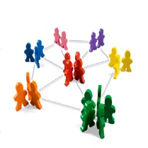**C.E.S. PBIS Coaches Network**

*8:30-11:00*

*40 Lindeman Dr. Trumbull*

***Remember to RSVP☺***

The network offers an opportunity for PBIS team coaches to gather, along with PBIS trainers, to explore effective coaching practices that support efficient, relevant and doable PBIS systems in their schools. Please ***RSVP by replying to this e-mail by 10/24/17*** so we will be sure to have enough materials. To continue to offer the network at no charge, please **bring your own coffee☺**

***Note:* Space limited to 50 attendees**

**October 27, 2017**

March 6, 2018

May 31, 2018

We are pleased to continue offering these sessions ***at no cost*** to PBIS school team coaches in the C.E.S. region. Come prepared to share, and take away, ideas on efficient, effective ways to maintain the positive impact of PBIS at your school.

Agenda: 10/27/17

* Refresher on role of coaches and resources: Tracey Lamothe
* Exciting updates from pbis.org: Christine Peck
* **Food for thought: Table Talks**
  + ***Beginning of year activities*** – building & maintaining momentum
  + ***Coaching Role*** – what works well? Challenges? Fostering “Sustainers”
  + ***Check-in /Out*** – Top dos and don’ts
  + ***Catch ‘em early*** – proactive steps to prevent increases in problem behaviors

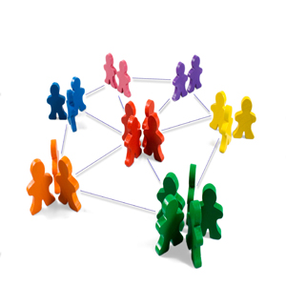C.E.S. PBIS Coaches Network

Table Talk – October 27, 2017

Coaching roles, responsibilities and activities

*Questions to facilitate discussion if needed:*

1. To what extent do the guidelines and content in the excerpt of the ***Coaches Workbook*** provided match the coaching practices in your school?

* What’s working well, strategies, ongoing activities?
* Are there gaps that seem to impact achieving desired outcomes?

1. What **challenges** (in the context of PBIS coaching) exist in your district or school?

* What actions may be taken to overcome them?
* What support is needed?

1. What **successes** have you had promoting PBIS in your district or school community?

* Communication to families, school board, community?
* Connections to school and district improvement goals?
* Sharing how PBIS relates to other school/district initiatives? Protecting resources?

C.E.S. PBIS Coaches Network

Table Talk – October 27, 2017

Catch ‘em Early: October Catch

*Questions to facilitate discussion if needed:*

1. What surprises you in the article provided? What resonates with you?
2. What indicators does your team monitor to identify students who may benefit from more intensive supports? How do the article recommendations and data connect to current reality at your school?
3. Are there patterns in the types of problem behaviors at your school? Do they include defiance and disrespect?
4. How might this information help your team improve intervention planning?

C.E.S. PBIS Coaches Network

Table Talk – October 27, 2017

CICO dos and don’ts

If possible, take a look at the article online to see the video illustrations for each of the 7:

[*https://www.pbisapps.org/community/Pages/7-Dos-and-Don'ts-for-a-Successful-CICO-Program.aspx*](https://www.pbisapps.org/community/Pages/7-Dos-and-Don'ts-for-a-Successful-CICO-Program.aspx)

*Questions to facilitate discussion if needed:*

1. What surprises you in the article provided? What resonates with you?
2. What is the current status of CICO at your school? What are the challenges? The successes?
3. Which of the 7 dos and don’ts may be helpful to improving CICO at your school?

C.E.S. PBIS Coaches Network

Table Talk – October 27, 2017

Fostering “Sustainers”

*Questions to facilitate discussion if needed:*

1. What surprises you in the article provided? What resonates with you?
2. Which category best describes where your school was in year 2 (or so) of implementation? Now?
3. If your school needs a boost to continue to progress, are there ideas in the article that may be helpful?
4. If your school has sustained implementation over time, what factors have contributed to your success?

Coaches Network Feedback: 10/27/17

Three—Two—One



* What are ***three*** new ideas/understandings you gained from today’s session?
* What are ***two*** topics you would like addressed at future sessions?
* What ***one*** feature of today’s format worked for you? What ***one*** feature did not work for you?