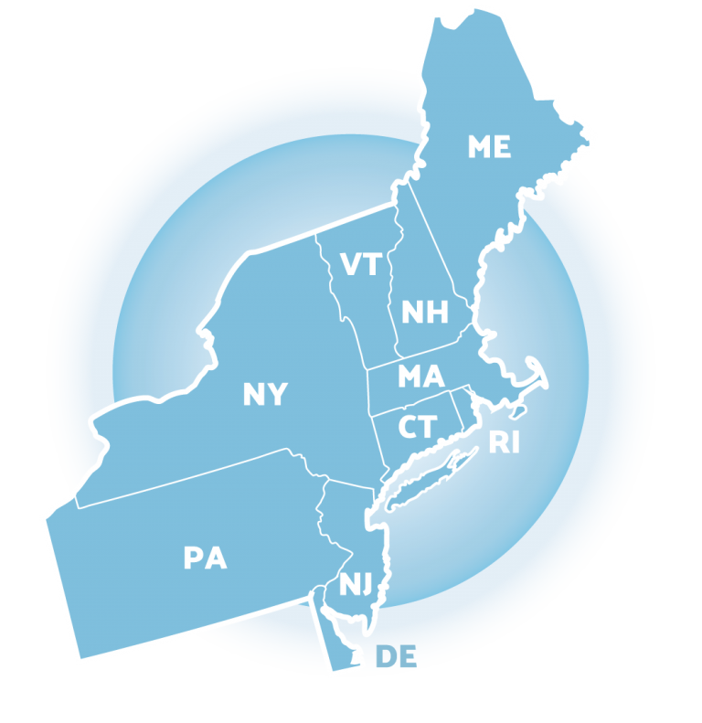

NEPBIS Trainer Re-endorsement Checklist

To maintain your endorsement, every 2 years you are required to:

- Submit one 20-30 minute training video demonstrating NEPBIS content accompanied by a self-evaluation using the DOT-Q
- Submit training evaluations provided by participants of your training
- Submit fidelity data (e.g. TFI, BoQ, ECBoQ) for at least 1 school you have worked with in the past 2 years.
- Participate in ToT Booster Sessions
- Attend two PBIS conferences each year
Please submit your re-endorsement materials here: https://uconn.co1.qualtrics.com/jfe/form/SV_6Xt9w3A1D6QWvZ4

